**Angular –** *PluralSight* ***Deborah Kurata***

**CLI Commands:**

>ng new BigPic - Create a project BigPic

>code . - to enter the editor (Visual Studio code for my case)

>ng g c About - to create a component About in the project along with unit test.

>ng serve - the server started

**Subjective & Situational Benefits:**

-Framework

Routers, http, forms, rxjs etc

Less decisions

-Uniformity

Google backing

TypeScipt

**Basic Features:**

Progressive web applications

Lazy loading

Forms library - Fully featured

RXJS library - very modern library for asynchronous features

Fully Featured Routers-modern frameworks

Animation- page to page, move items

**Advanced features of Angular:**

Server-side rendering - Imp for SEO server created html/CSS and sends to the browser. so it is faster

Mobile - Friendly to create angular mobile apps

Angular Language Service - Get intelligent info on templates and avoid typos

ngUpgrade - Library used to apply web migration from Angular JS to Angular

Low cost development

Performant

Full Framework

Uses TypeScript

Many modern frameworks

Server-side rendering

Upgrade to modern frameworks

**Architecture:**

Dependency Injection

Custom components - selector

Directives - HTML attributes ex: trigger/appear-on-hover

Templates inline with components

State changes – Zone.JS

User interaction

http request

timer fires

**Rendering options:**

- Brower-platform

-Browser-platform-Dynamics

-Rendering targets

-Browser/DOM

-Server-Side

-Native Mobile Apps

-Native Desktop Apps

-Others

**TOOLING**

-CLI

-Server-side rendering

-Mobile/Native Frameworks

-Testing

-AOT compiler

-Editors

The Angular CLI: handles below capabilities

Running a JavaScript Application:

Module Handling

Bundling

Minifying

TypeScript/ES6 Transpiration

Browser Shims

Zone.js

**CLI capabilities:**

Create new app

Create New components

serving up the app

Lining

testing

Building

**Server-Side Rendering with Angular:**

Main benefit:

Performance:

-Initial Download Size

-Render time

Search Engine Optimization

Operation modes: ser side rendering

Full pre-rendering

Dynamic pre-render

Client-side switch

-Download App

-Hidden Div.

-Boots

-Replays Events

-Swap Display

**Mobile & Native Frameworks:**

Mobile

-Ionic

-Native script - fast and popular

Desktop

-Electron - to build VSCode

**Testing tools:**

Angular testing Tools

-Karma for unit testing

-Protractor - web automation tool for end-to-end testing

Alternatives:

-Jest

-theIntern

-Cypress

**Angular testing utilities:**

-TestBed

-Async & fakeAsync

-MockBackend - mock http server

**AOT Compiler**

JIT process (Just-In-Time process) was older versions

AOT Process - Ahead Of Time process saves time - Angular uses AOT Compiler

**Editors**

Creates faster and easier

-TypeScript

-Better IntelliSense

- Catch Typing bugs

Angular Language Services

-VS Code

-WebStorm

-Sublime Text

**Tips and Tricks, Gotchas:**

-Decorators are having different type of syntax. Easy to get confused

-Type script has its own learning curve

**Custom Pipes:**

Pure (when input changes) Vs impure (every change detection cycle)

Module API - everything goes wrong if we do any wrong in this.

Imports

Exports

Bootstraps

providers

declarations

and more.....

Multiple Modules:

Feature Areas

Lazy Loading

Difficulties:

- Routing

- Importing and exporting

Cryptic Error Messages

-Frequent

Frustrating

Slow download

**Build:**

Complex

Important to tune

Affects performance

**Delivery size:**

>1mb

Constant improvement

CLI

**RxJS**: New technology with asynchronous operation:

-Promises Vs observables

-Self-subscribe or not

-Forgetting to subscribe - code won’t do anything

-Accidentally making multiple http req

-Hot Vs cold observers

-Shared observables

**Tips & Tricks:**

-Use the CLI - to mitigate many issues

-Follow the style guide

-Do sorting & filtering in your components

-Learn & use Typescript

-Learn & use Ngrx

-Learn Webpack

Use Lazy loading

Use VS Code or another modern editor

Don’t touch the DOM directly

Understand what u are sending down to the browser. To maximize the performance

Use immutable or observable data to max performance where appropriate.

**Course Outline**

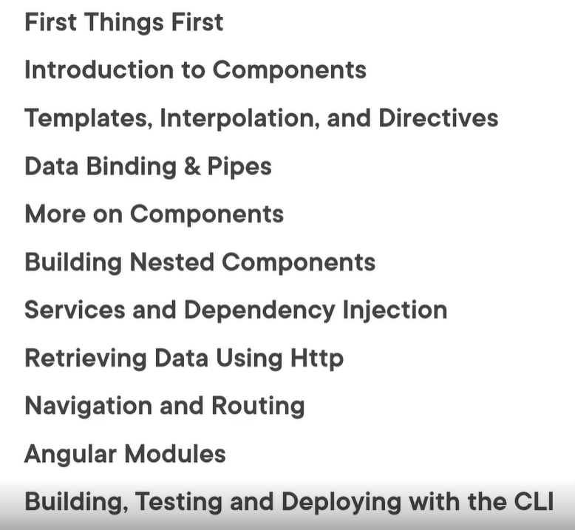

Install VS CODE

<https://code.visualstudio.com/>

Install NPM (Note Package Manager) – can install libraries and packages, applications

<https://node.org/en/download> >= 6.1 version is required

>npm install myProject

>npm -v (to check version)

Angular CLI: **Package.JSON** downloads all the necessary packages for development.

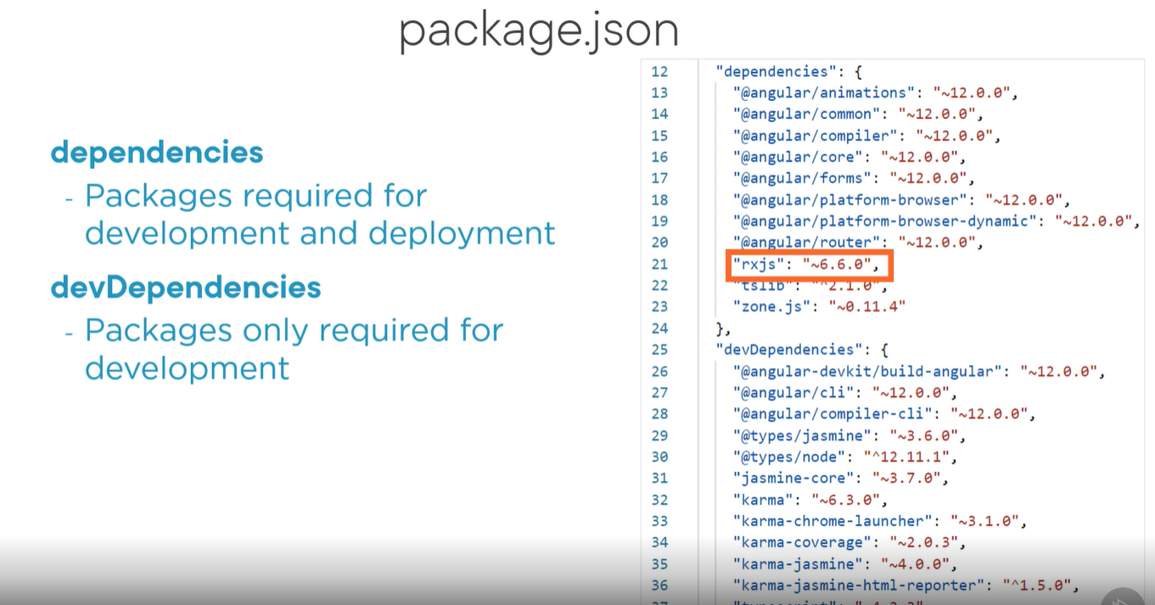

<https://github.com/DeborahK/Angular-GettingStarted>

Get code from above GIT

C:\users\rmanoha3>**npm install -g @angular/CLI** (to install angular globally using -g command) in command line

<https://app.pluralsight.com/course-player?clipId=6f97c3df-0511-4f83-86f7-411bd1ad2603>

<https://github.com/DeborahK/Angular-GettingStarted/tree/master/APM-Start>

Create new application after global install:

* Ng new apm-new –prefix pm (prefix pm for product management. This is used in future)
* Say no for angular routing

* Use – CSS

Creates package.json

Now, navigate to **apm-new** folder

* Apm-new> code . (open the folder in VS CODE)
* Type >npm start (in VS Code terminal to start the application)
* >y to share the data
* Open angular application in <https://localhost:4400> ( or the link given after npm start)

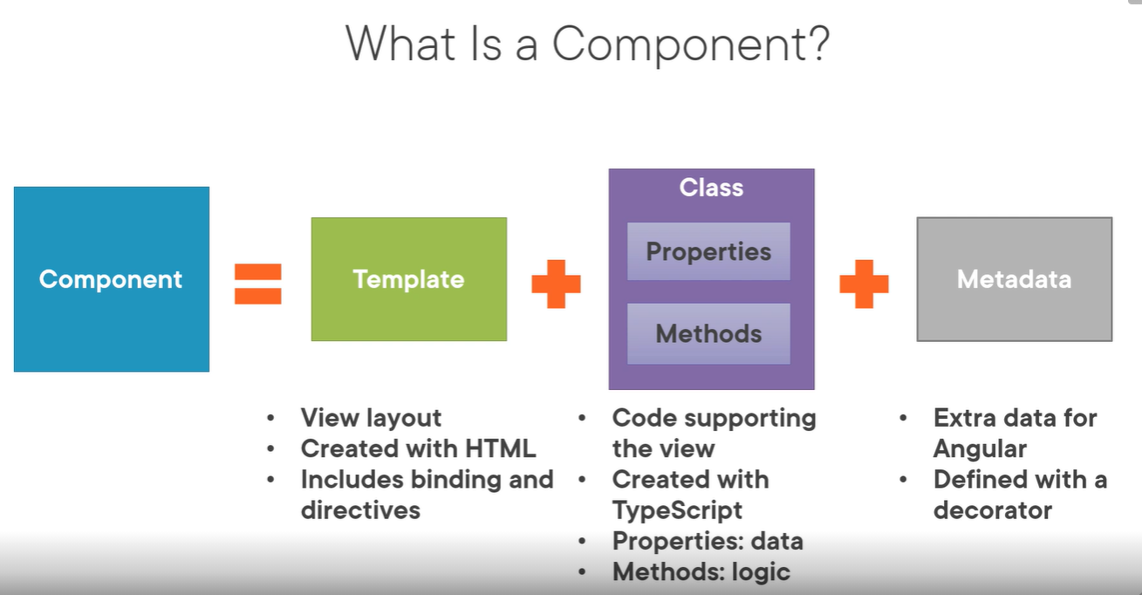

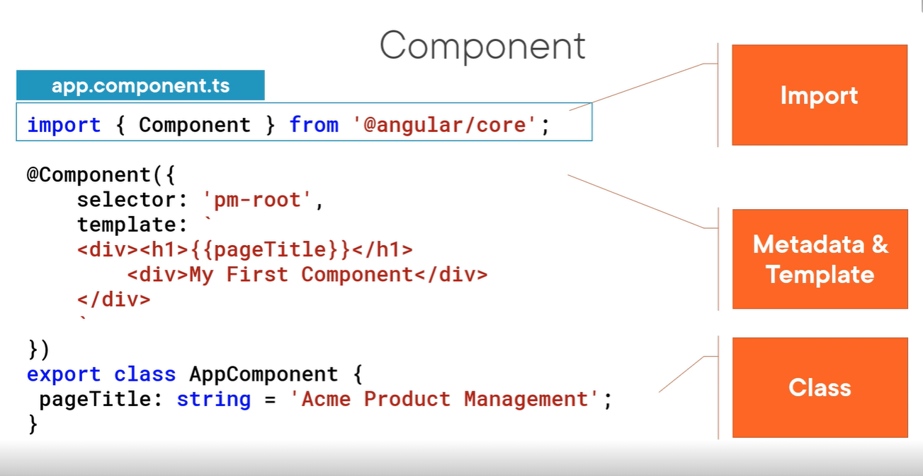

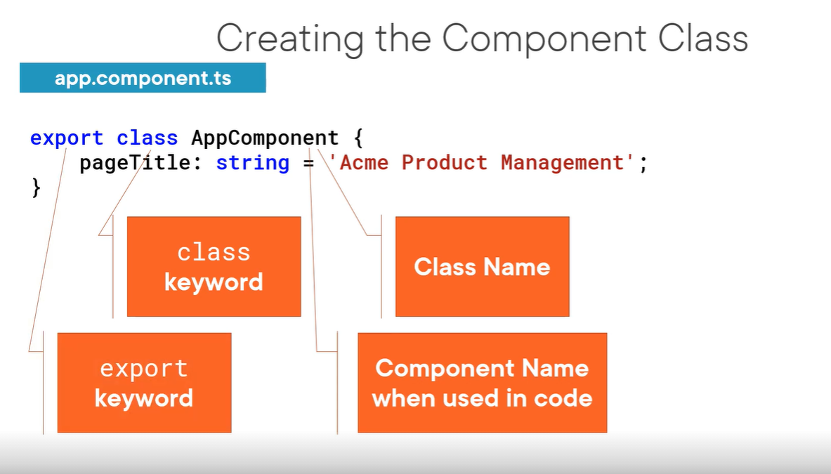

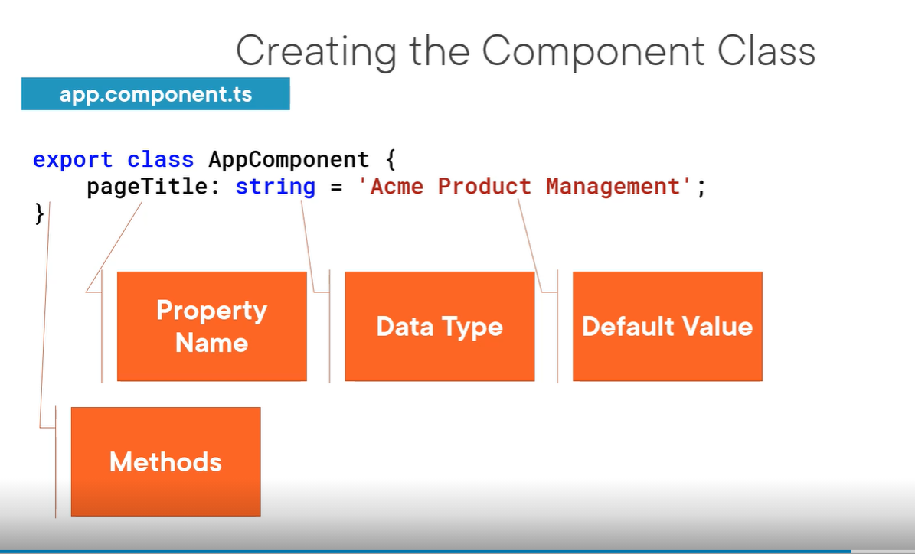

Decorator is a function that adds metadata to a class, its members.

Add decorator immediately to class.

Use @Component decorator to identify a class as component.

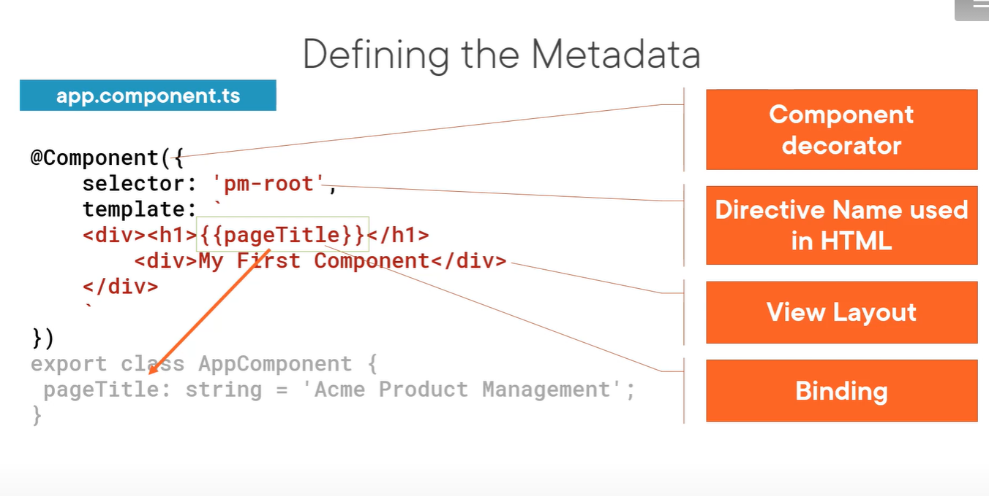

Import statement

* Define a class as component and import it from @angular/core

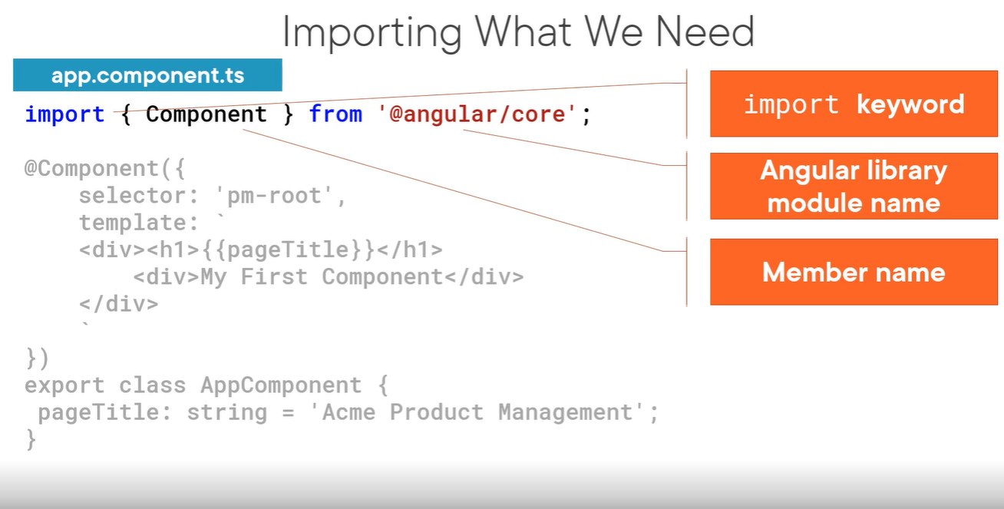

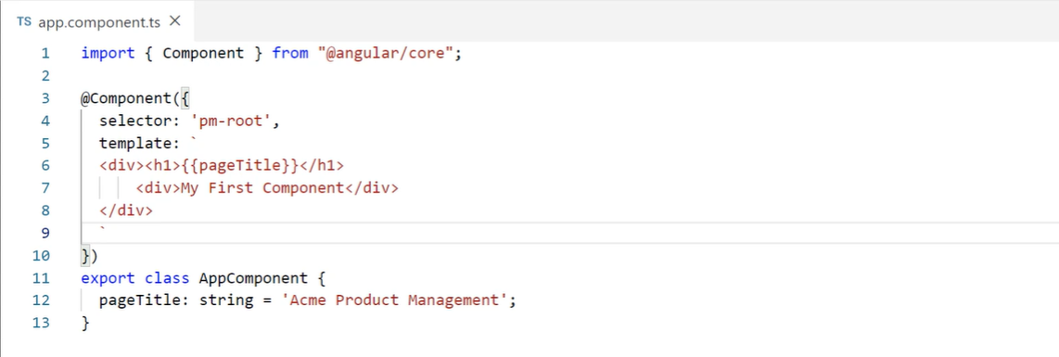

Bootstrap our APP component: We need to tell our angular to load our components is called boot strapping.

1. Host the application

2. Defining the angular module

<https://app.pluralsight.com/course-player?clipId=fc2a21e0-fb1e-4716-a099-5415eecb5a0c>

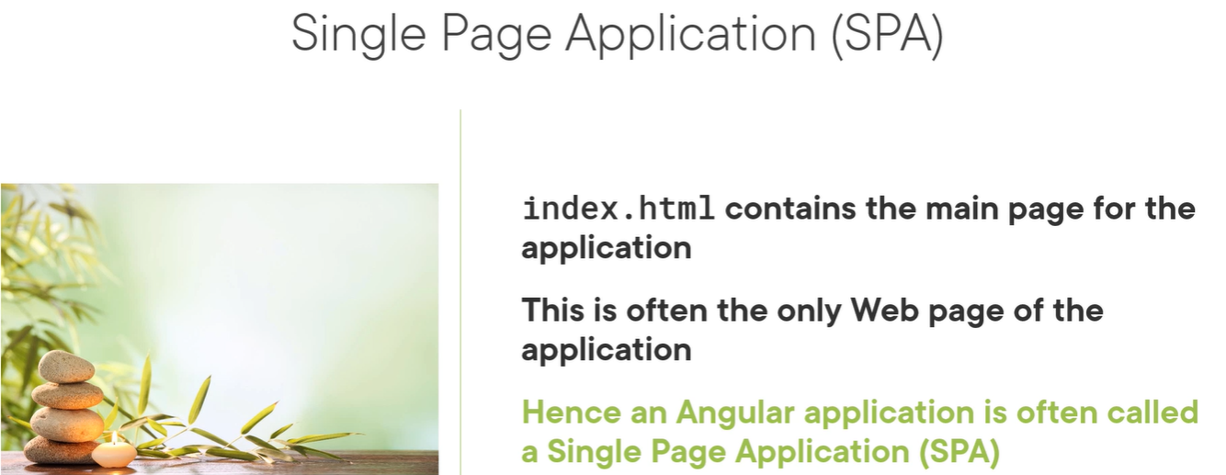

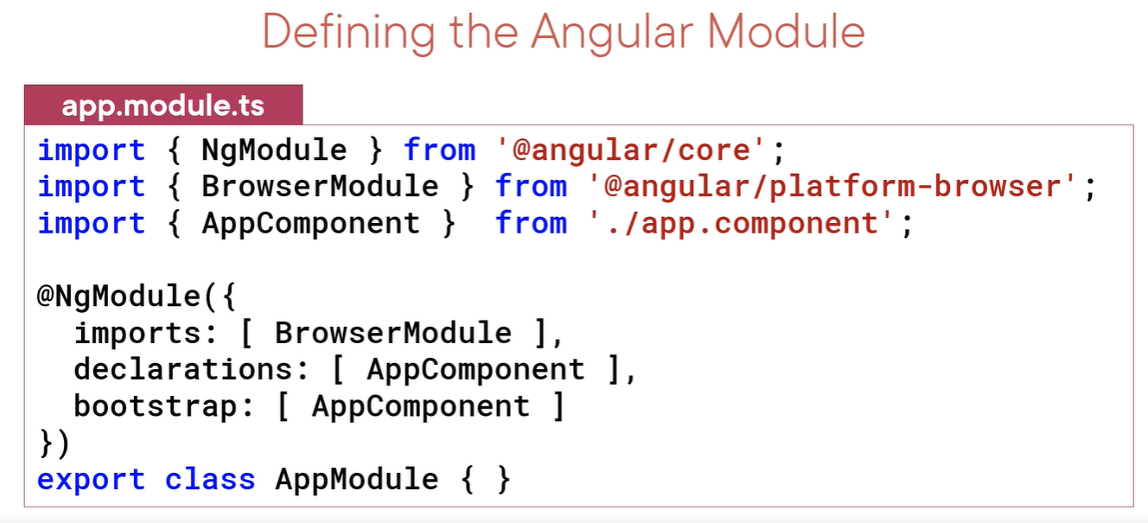

Setup index.html as our application page.

Debug the application on browser by setting up the break point: Press **F12** for inspect on browser.

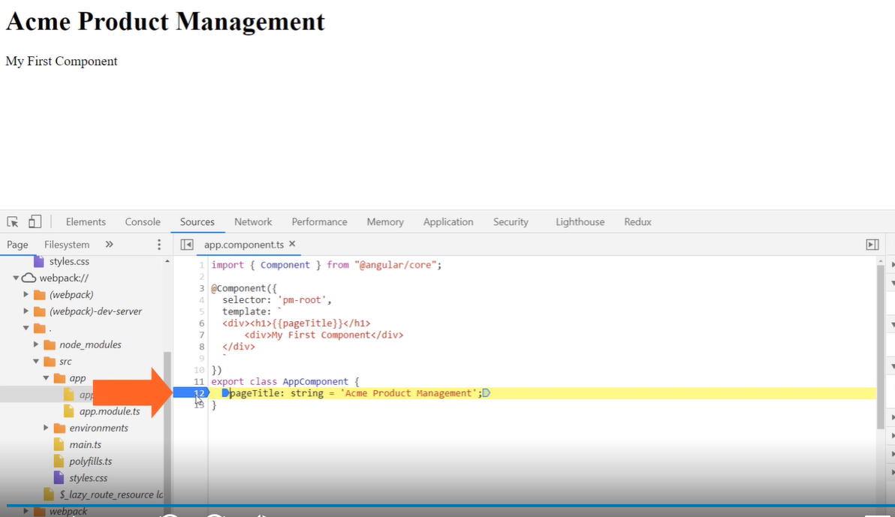

Set breakpoint and reset browser to debug the code.

Angular compiles our HTML templates and TypeScript components to JavaScript.

Compiler displays syntax error. Ex: case sensitivity issues:

Start with code editor to see the errors

See the terminal after compilation. First error might be the error for others.

Sometimes stop (Ctrl +C) and start (>npm start) the compiler

Use browser developer tools (press F12 on browser)

Recheck the recent code if there is still error. Ex: HTML tags improper, braces etc.

Checklist:

Decorator prefix - @

Correct HTML syntax

Import – tells where these members that component needs

Path must be in quotes

**Templates Interpolation and Directives**

1. Data binding
2. Angular directives (custom html syntax)
3. Angular components (ex: image rotator etc)

Component = template + class (properties and Methods) + Metadata

**Product List Component:**

1. Defining a template in a component:

“Inline template <h1> {pageTitle}</h1>”

1. Define inline template with multiple tags
2. Linked template:

templateUrl:

‘./product-list.component.html’

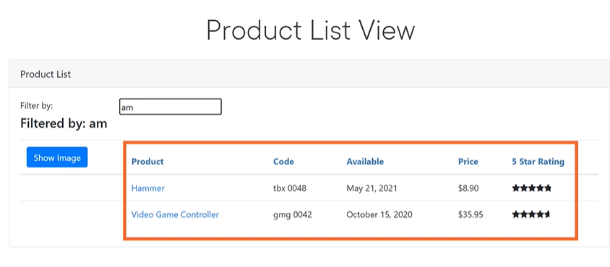

We use bootstrap for styling. Bootstrap.com

Fontawesome.com

To add bootstrap FAwesome >npm install bootstrap font.awesome

Once installed we need to import in the style sheet.

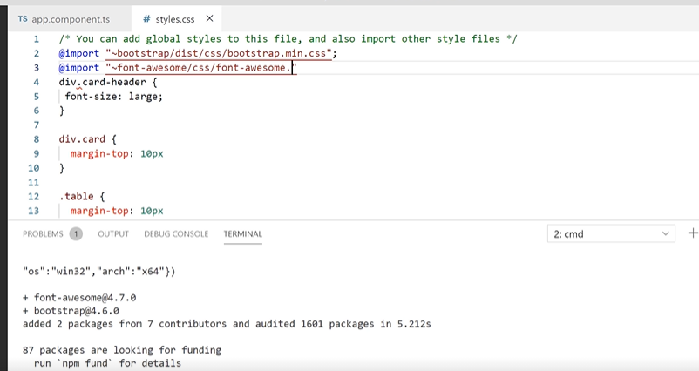

Now they are available to any external application.

Add new folder in ‘App’ folder as ‘products-list.component.html’. Write below code in it for product. Leave <tbody> as empty for now.

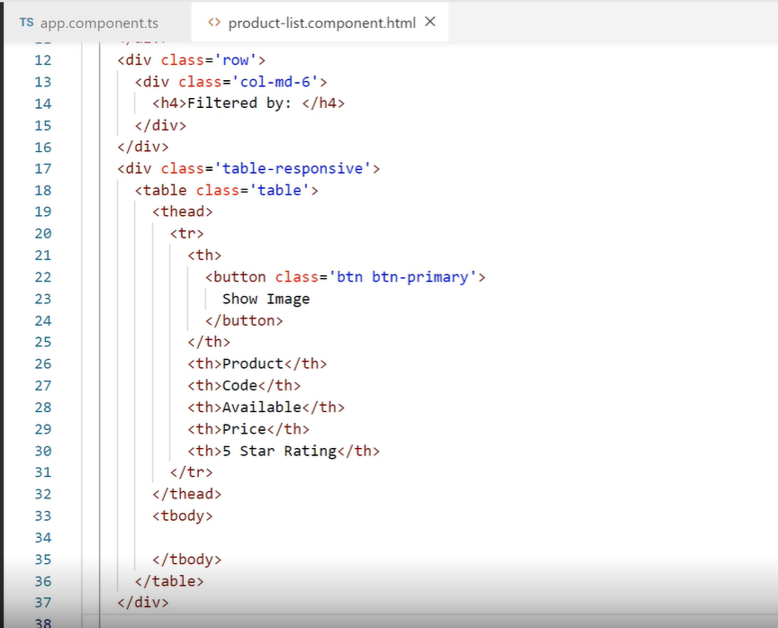

Component has class, decorator and import as shown below:

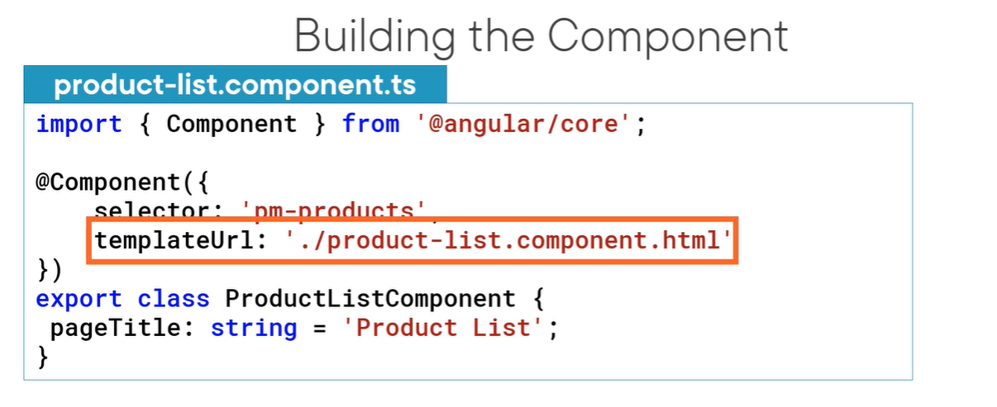

Create component file: in products folder as : ‘product-list.component.ts’

Create a class: ProductListComponent – export class (to available to other components)

Import components.

Decorator - @Component

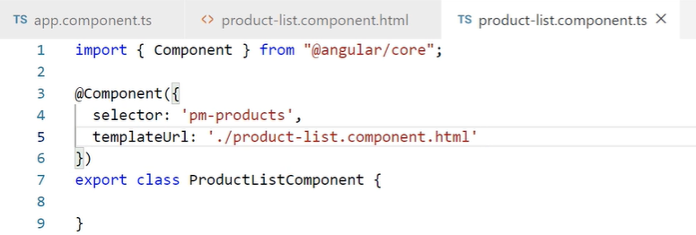

Every application must have AppModule and App component is

Component belongs to only 1 angular module.

Also imports browser module to run this app in the browser.

When a component contains a directive, it determines which directive it belongs to.

We can declare in angular module as below or import from another module.

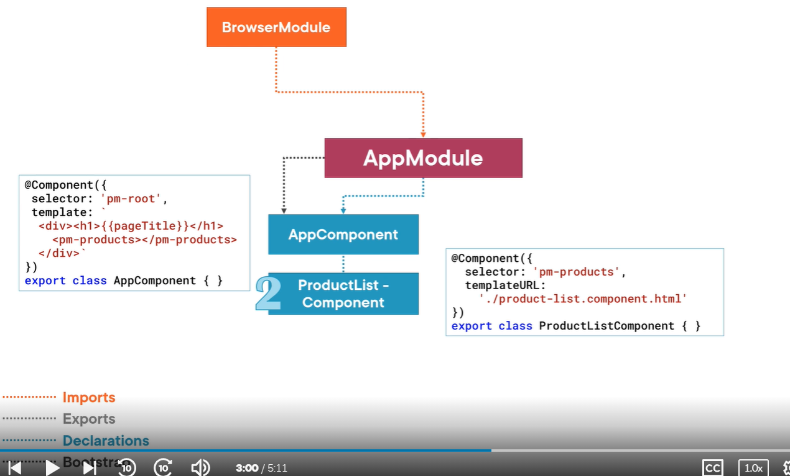

Replace the <div> tags with <pm-products> like below in app.components.ts module:

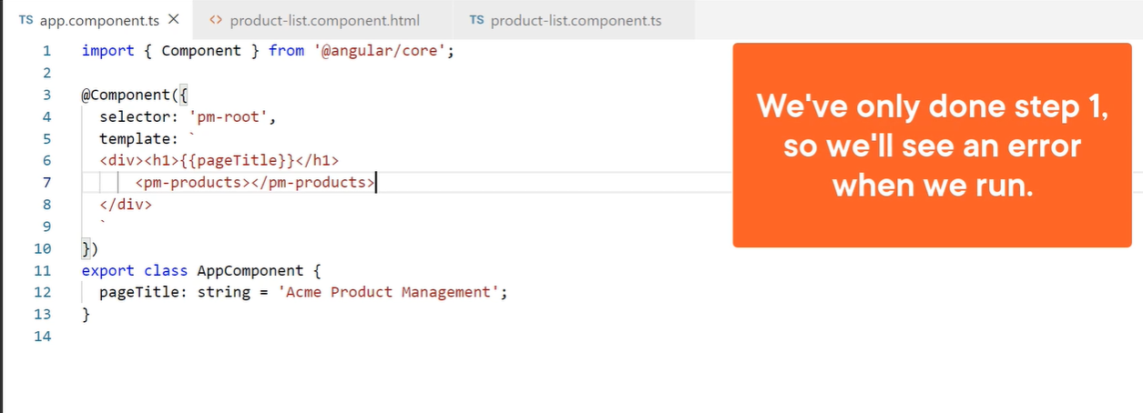

Now there is an error. We have to add ‘ProductListComponent’ to app.module.ts:

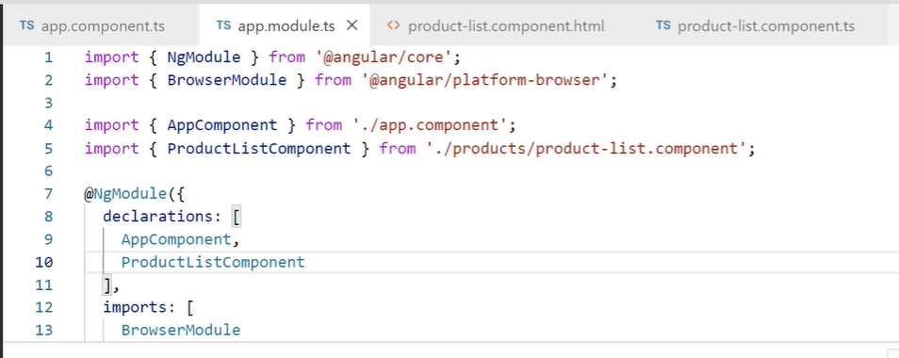

We got a page but not complete and interactive:

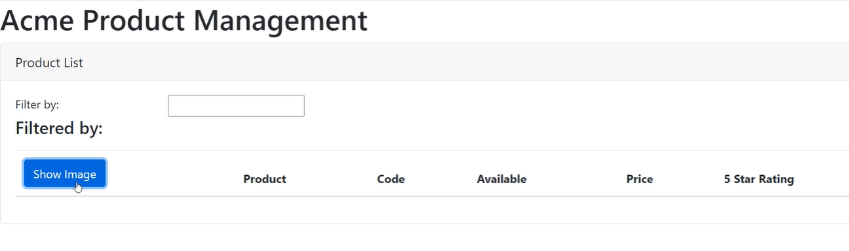

Now we are ready for interface ‘databinding’ and some built-in angular directives.

**Binding**: Coordinates communication between the component’s class and its template and often involves passing data.

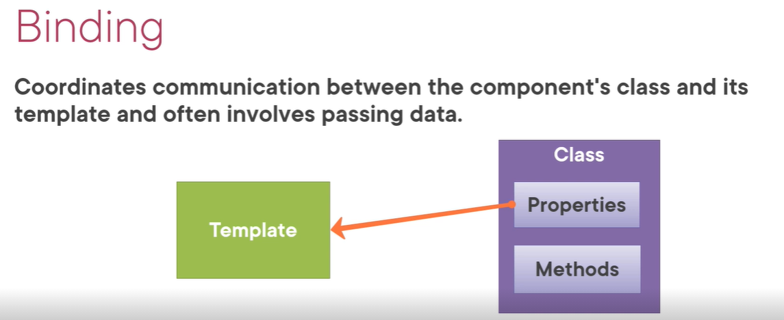

<https://app.pluralsight.com/course-player?clipId=bdbace4d-ba53-4158-91a5-104452a7e1b7>

Interpolation – Uses {{ }}

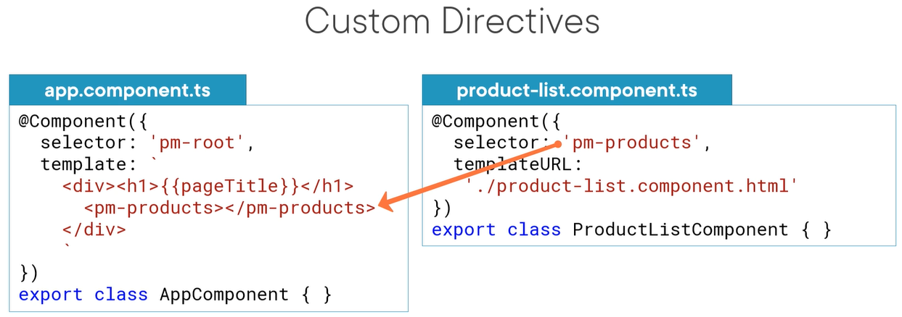

Angular built-in Directives:

*ngIf

*ngFor

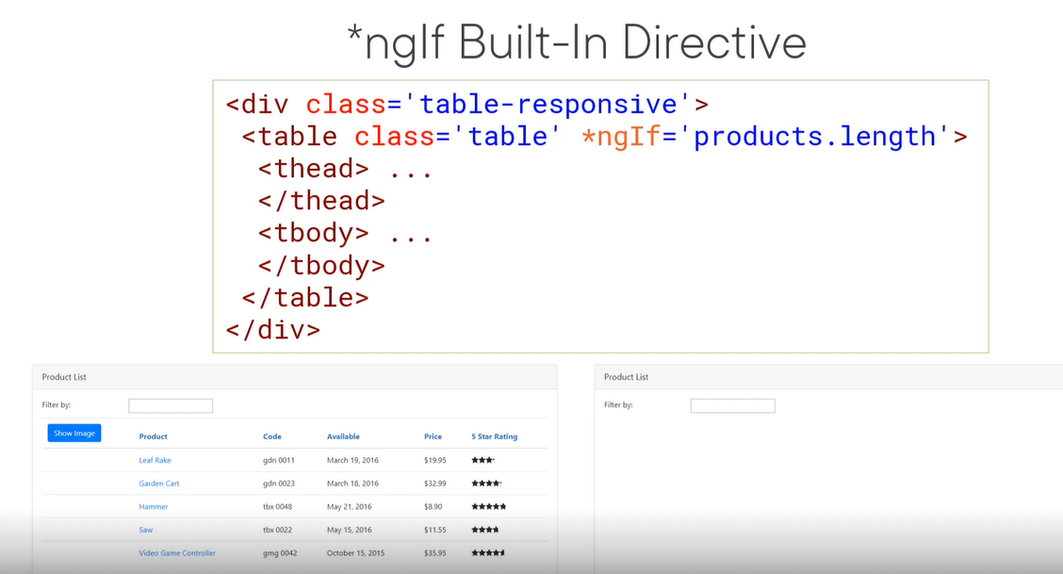

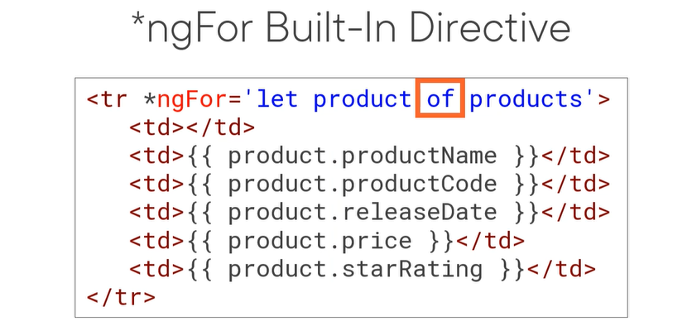

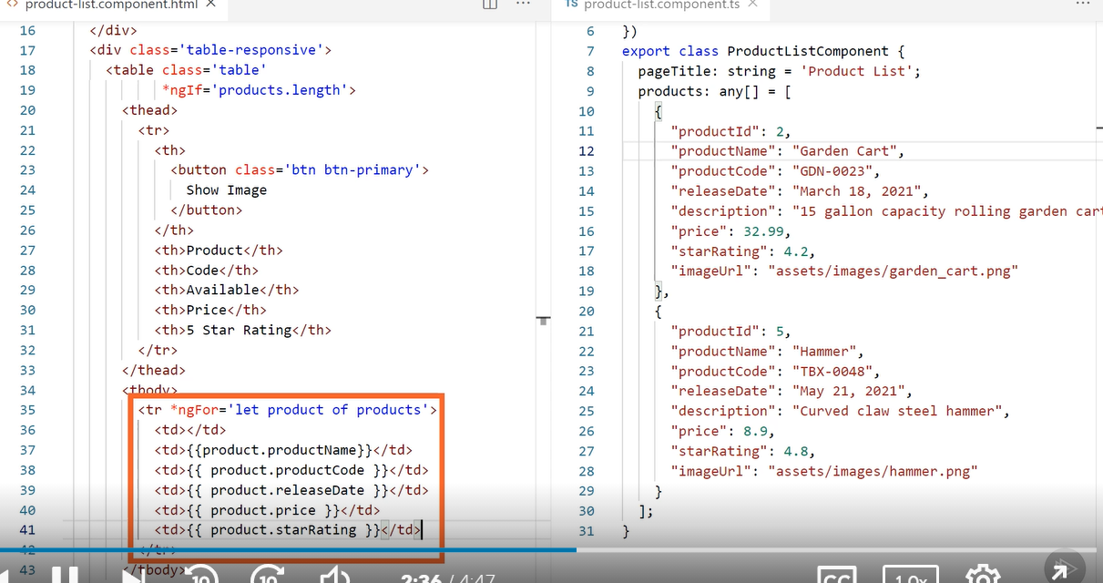

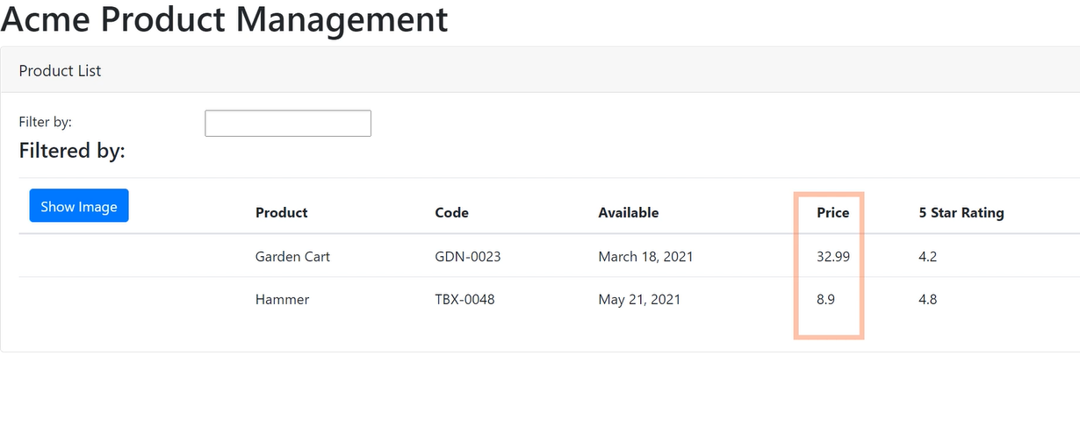

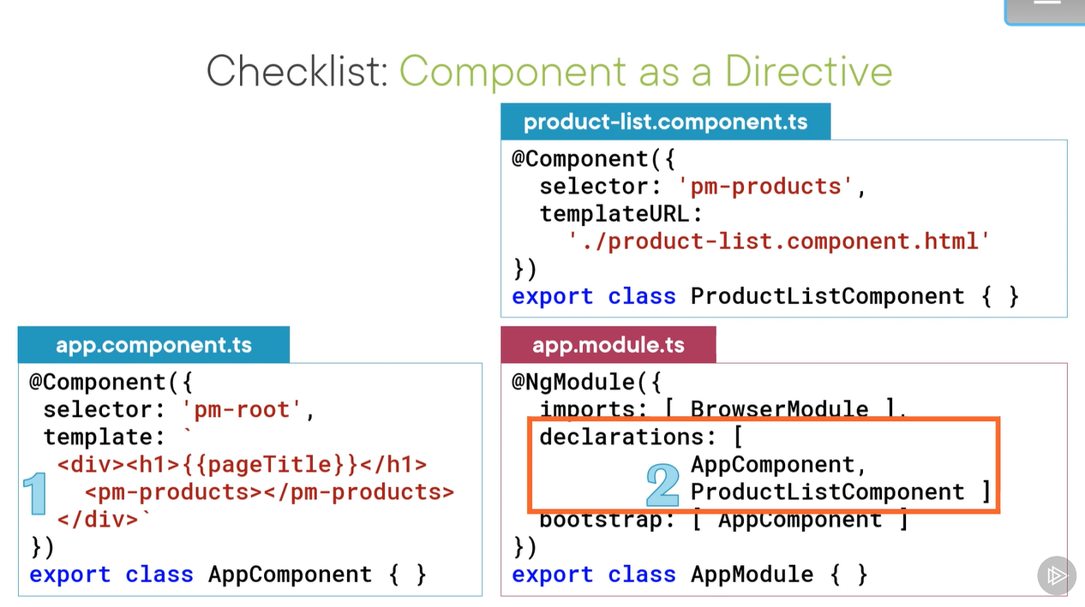

Use inline template while building shoreter template. Use template property. There is no design time syntax setting . so, see the syntax properly.

First use the directive as element (pm-products) as component.

Declare component in module.

Angular data binding :

<td>{{ product.productName }}</td>

**Data Binding & Pipes**

Property binding

Handling events with Event Binding

Handling Input with Two-way Binding

Transforming Data with Pipes

1. **Property binding**: below are the examples

<img [src]=’product.imageUrl’>

<img scr={{product.imageUrl}}>

<input type=’text’ [disabled]=’isDisabled>

<img src=’http://myImage.org/{{product.imageUrl}}>

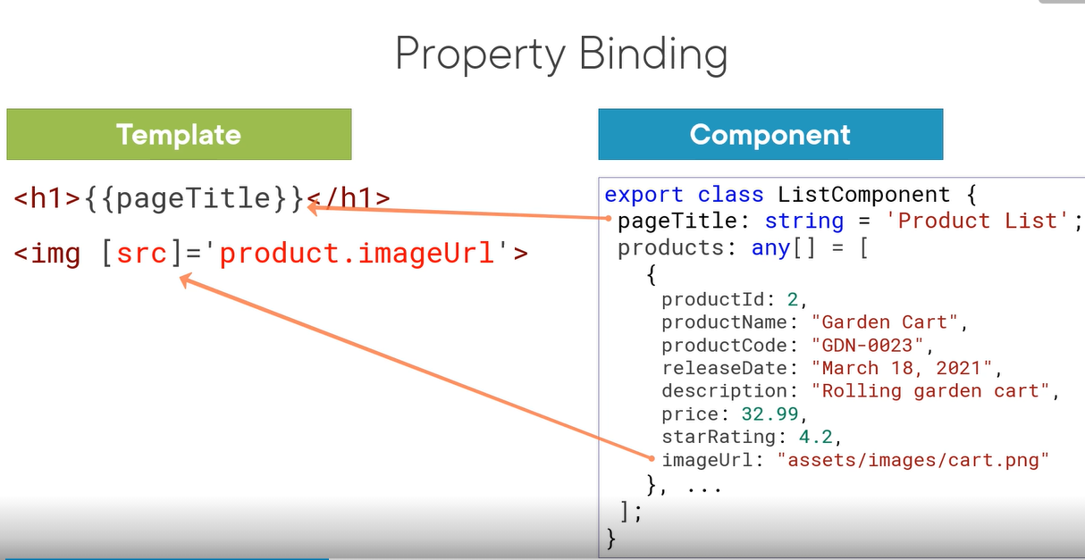

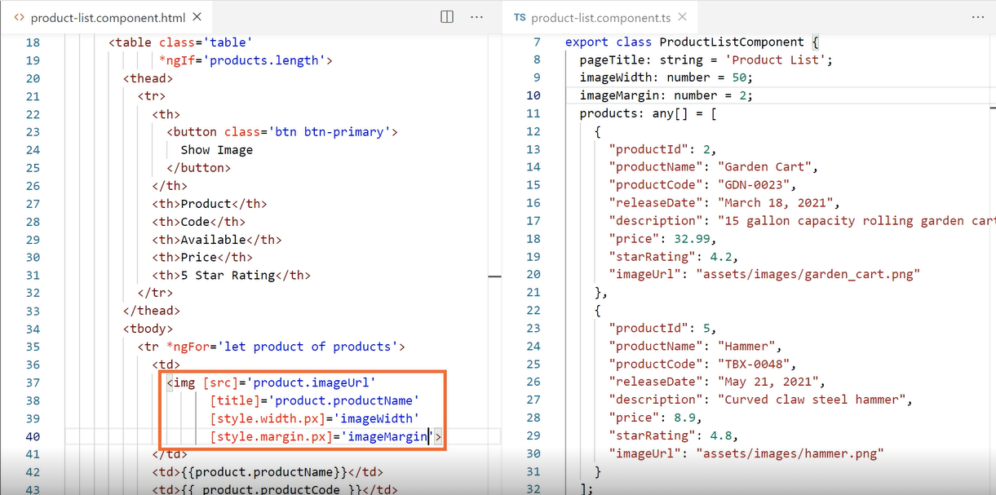

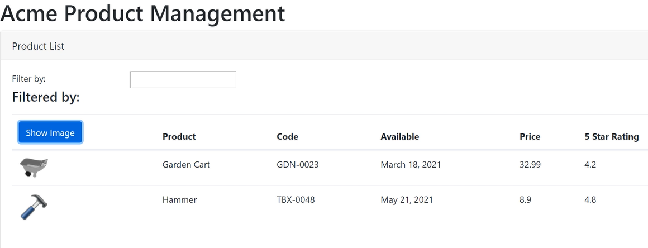

Let’s hookup buttons. Add response to user events.

Event bind allows us to connect a method to component.

<button (click)=’toggleImage()”>

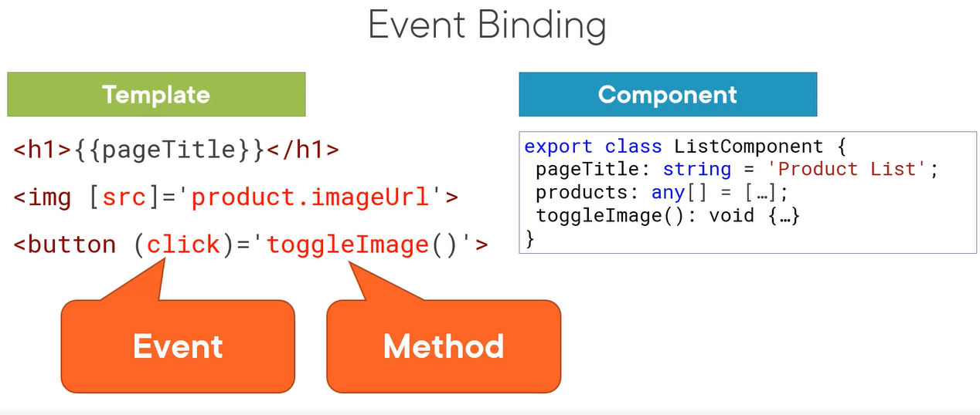

Impellent showImage button.

Property showImage default is false. Not to display the image when the page first called.

toggleImage(): void {

this.showImage = !this.showImage.

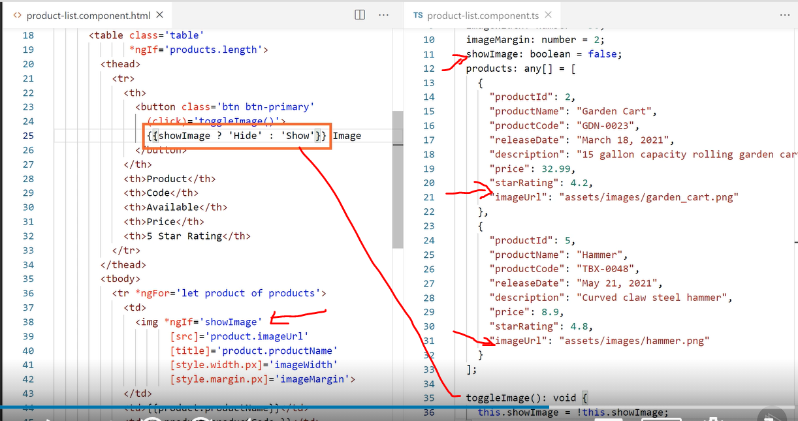

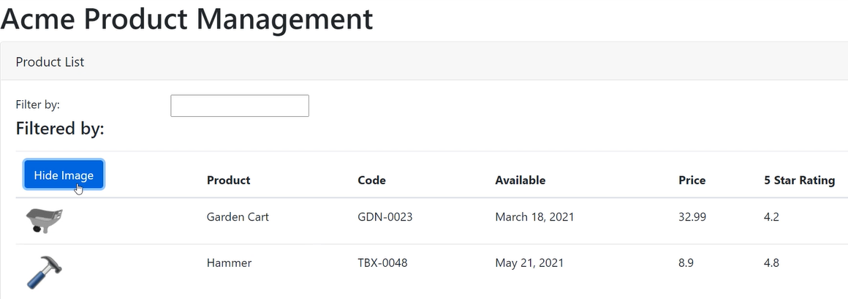

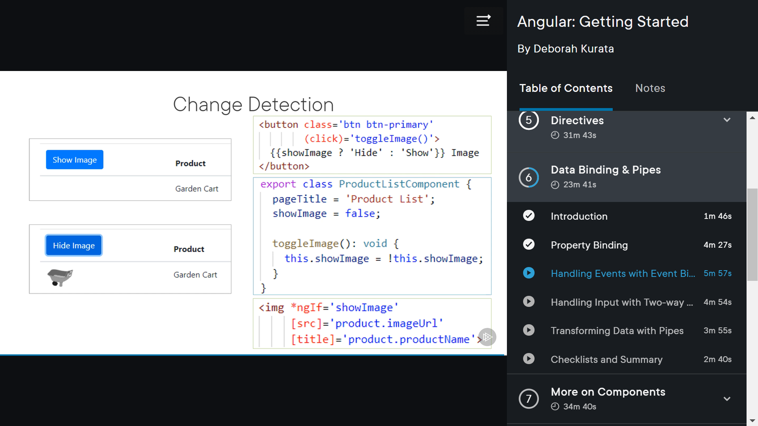

Two-way binding:

listFilter: string = ‘cart; (cart is the default value for filtering)

<[(ngModel)] =’listFilter’/>

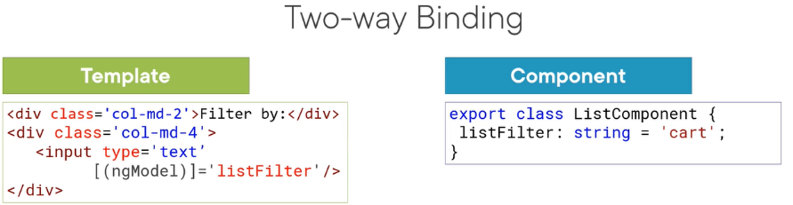

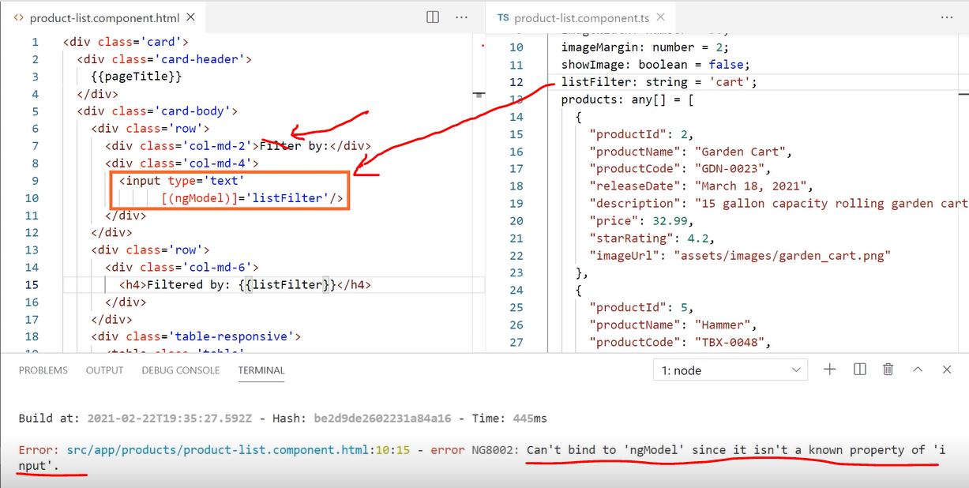

To export the directory we have to add :

Import {formsModule} from @angular/forms’}  
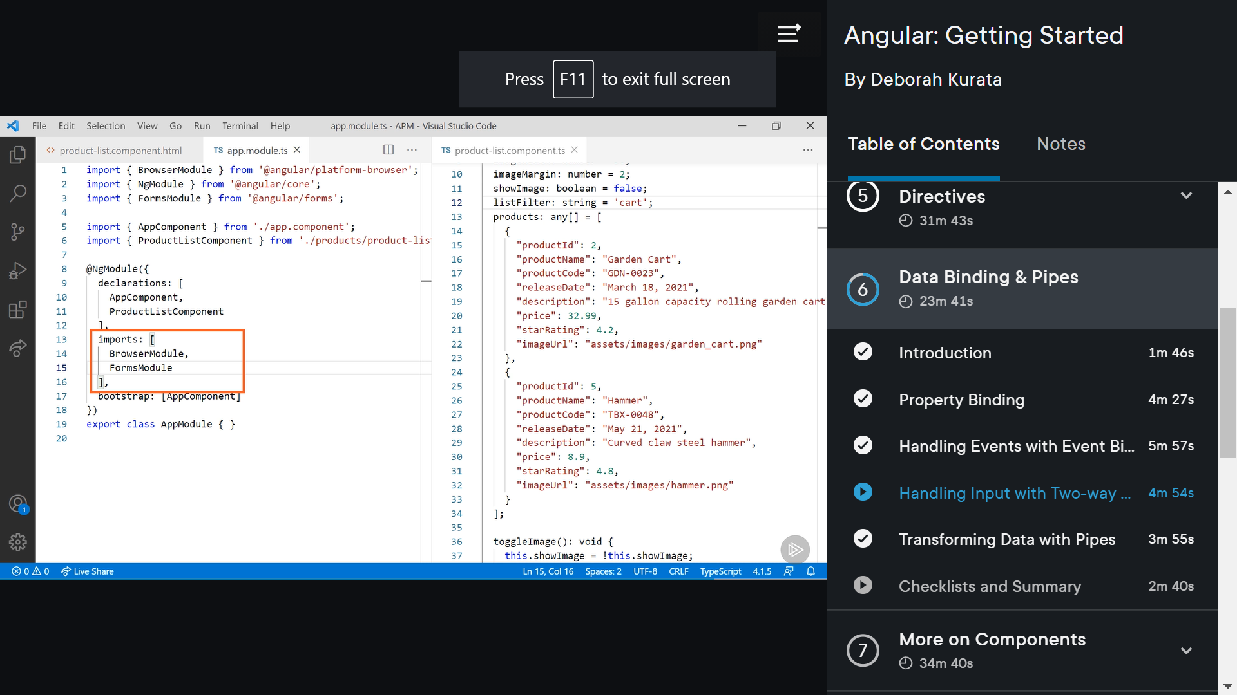

**Pipe examples:**

{{ product.productCode | lowercase }}

{{ product.productCode | currency | lowercase }}

{{ product.productCode | currency :’USD”:’symbol’:’1.2-2’| lowercase }}

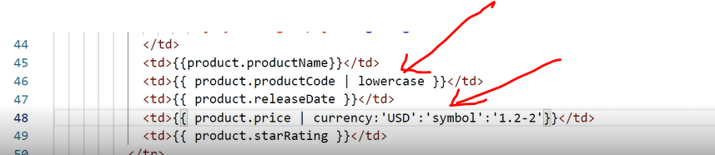

Data binding:

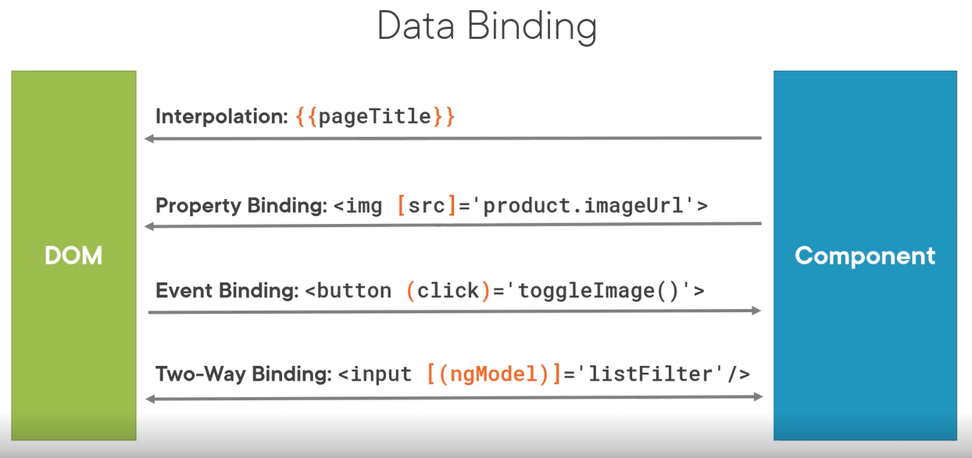

**Interfaces**: is a specification identifying a related set of properties and methods.

Interface is identified with ‘I’ at the beginning of the name (prefix) of the interface.

export key word is used to make use in other parts of the project can use this interface.

Ex:

export interface IProduct {

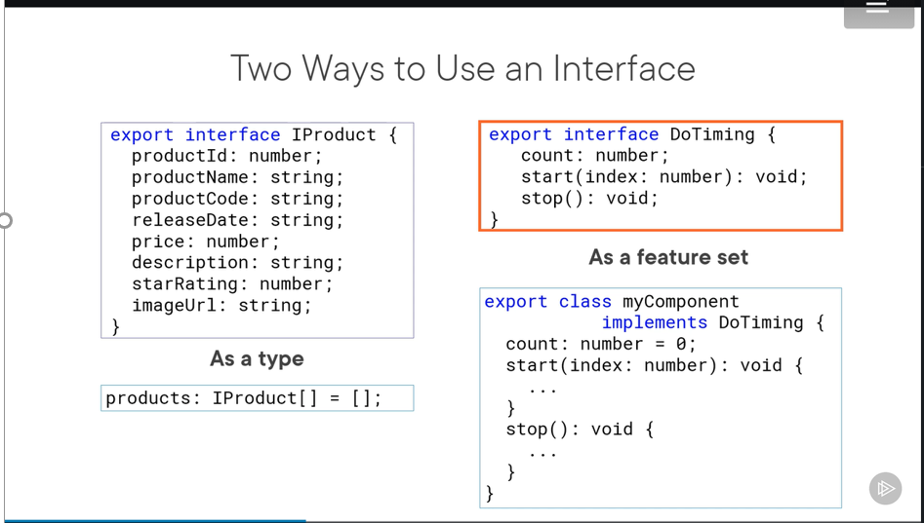

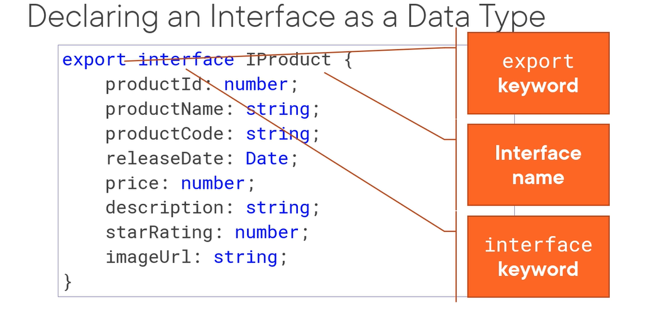

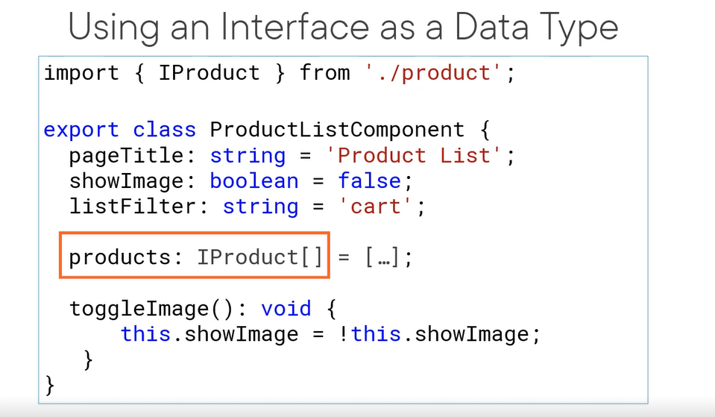

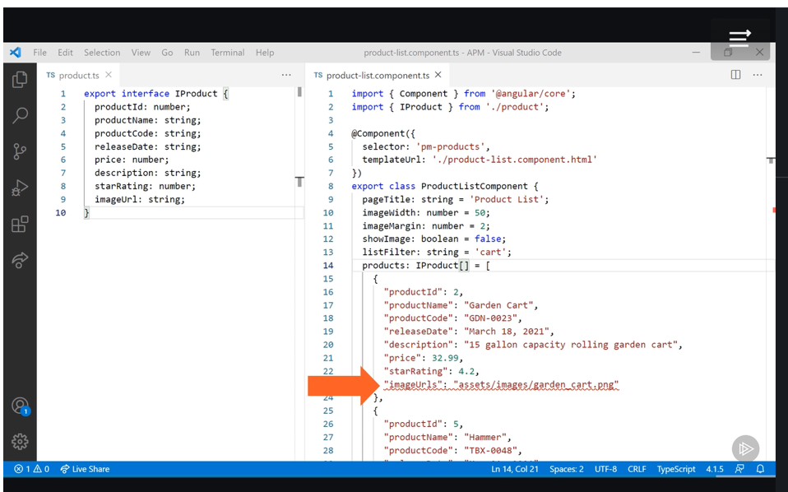



Encapsulating the component STYLES: add product-list.component.css in products folder:



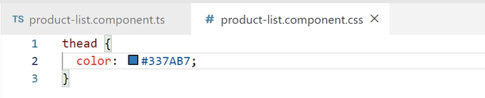

Use it in : product-list.component.ts

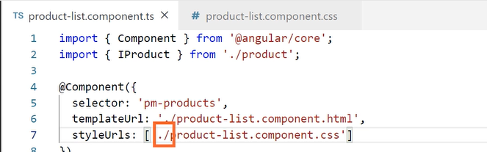

Lets review the results:

Now table header is blue bold letters:

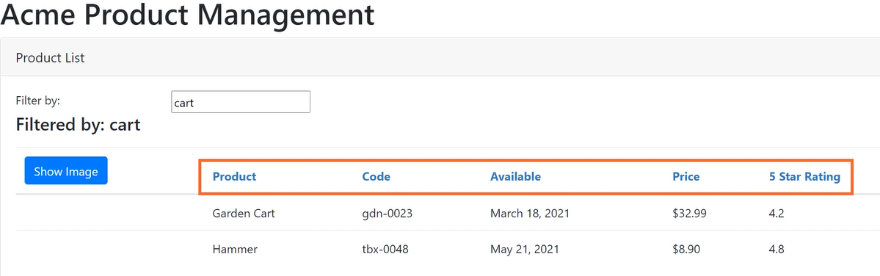

Life cycle hooks: is an interface we implement to write code when a component life cycle event occurs.

onInit – Perform component initialization

onChanges: perform actions after change to output properties

onDestroy: perform clean-up.

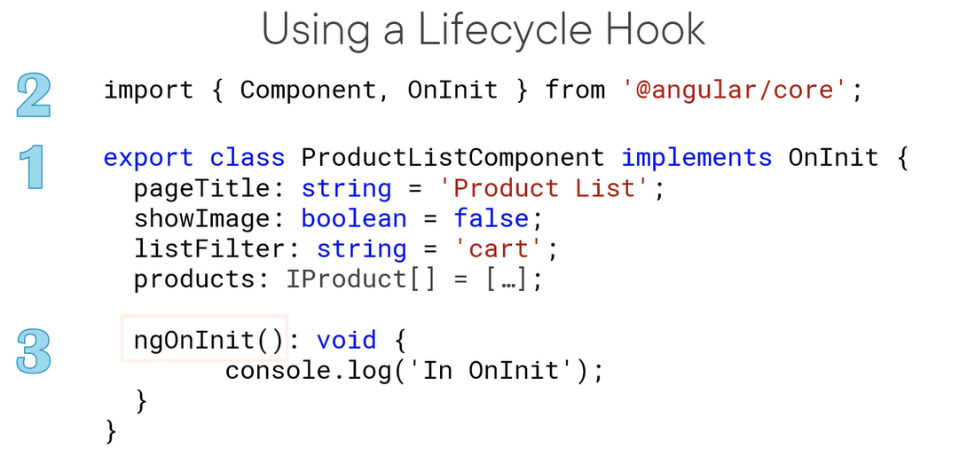

Using onInit:

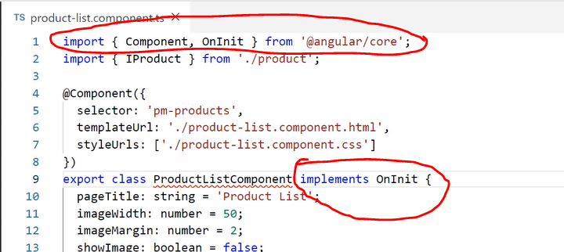

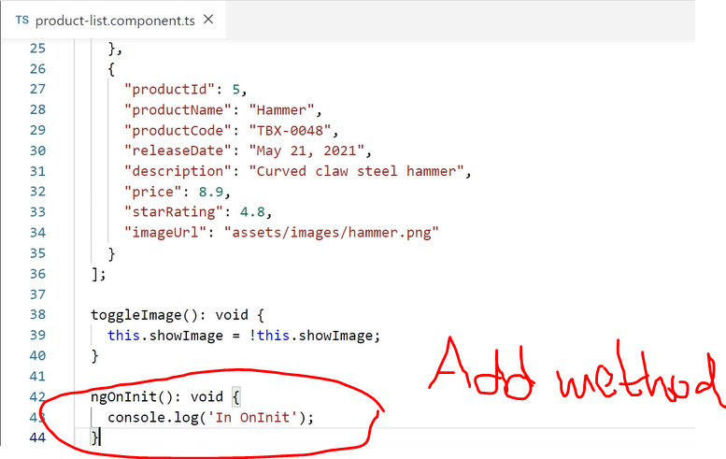

Transforming the data with Custom PIPES:

Example: Product code is ‘gdn-0023’ but customer wants to see with space like ’gdn 0023’.

Create new component: convert-to-spaces-pipe.ts in shared folder.

1. Step:

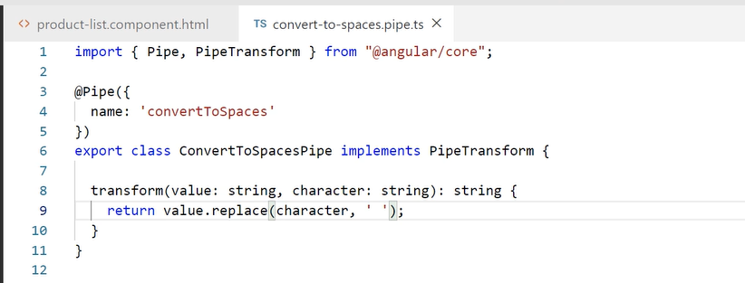

2 step:

Add pipe to the product doe like below:

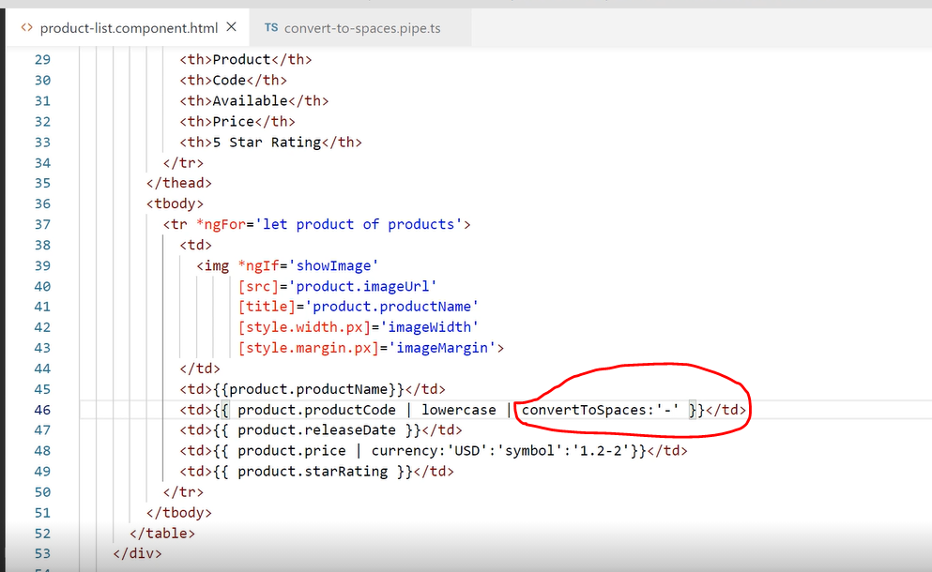

3rd Step:

Add pipe declaration to app.modue and import:

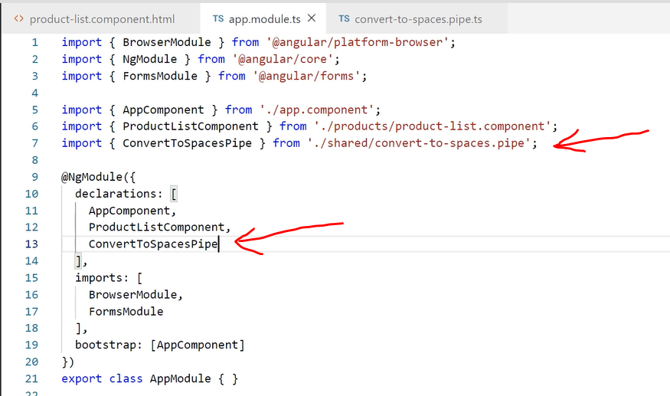

See the results:

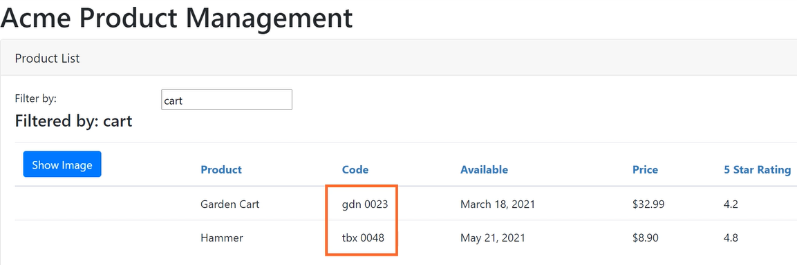

**Getters and Setters (JavaScript)**

JS Getters and setters: used for filtering the fields in the screen by defining property and class.

Ex: Convert value in currency, set it in private storage.

Step 1:

Delete default filter ‘cart’ from product-list.component.ts:

listFilter: string = ‘cart’; <- remove this line from product-list.component.ts and add

add Getter and setter for listFilter as follows:

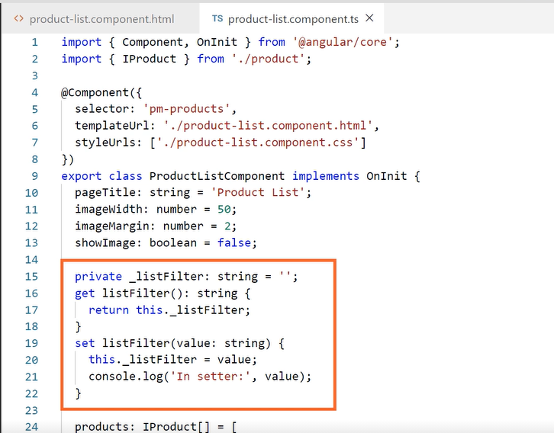

Set default value here in same component:

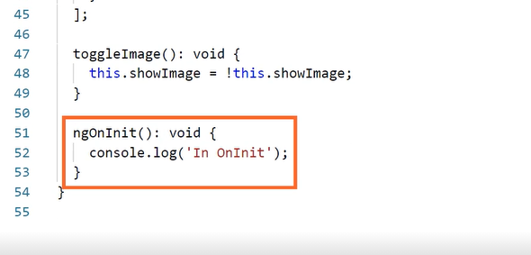

Change above code to initialize to ‘cart’ or any other initial value:

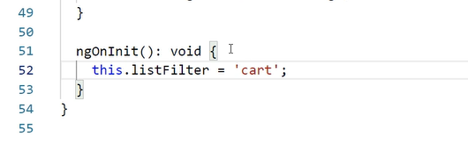

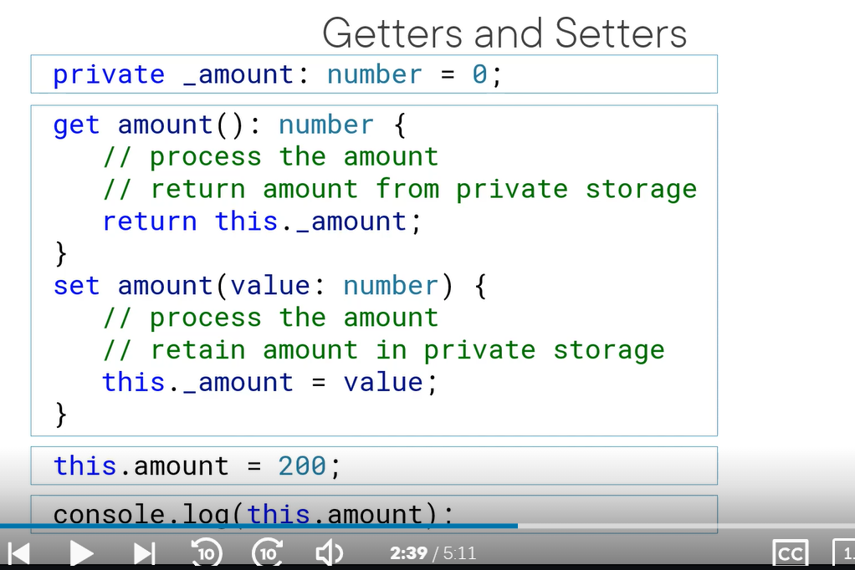

Filtering a list: use Java script filter method:

An arrow function is compact syntax for defining a function. Arrow function does need a name. see below example:

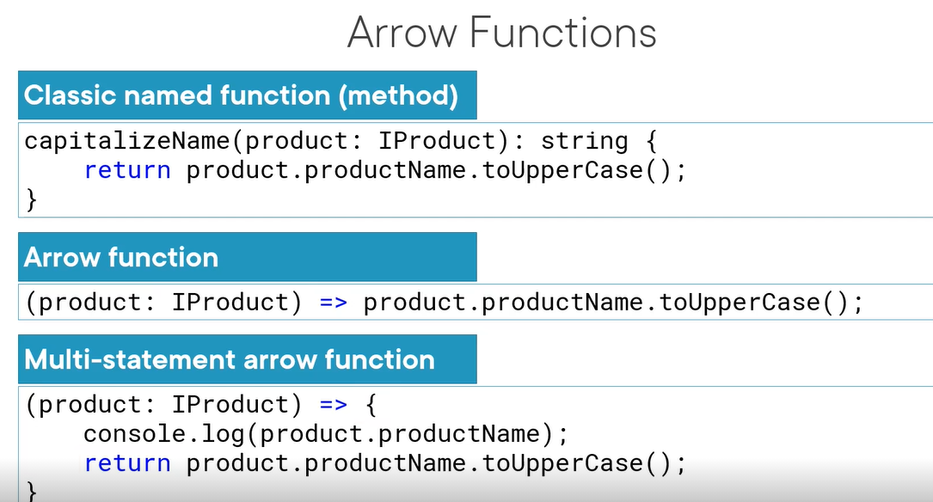

Step 1:

Add filter method in setter like mellow:

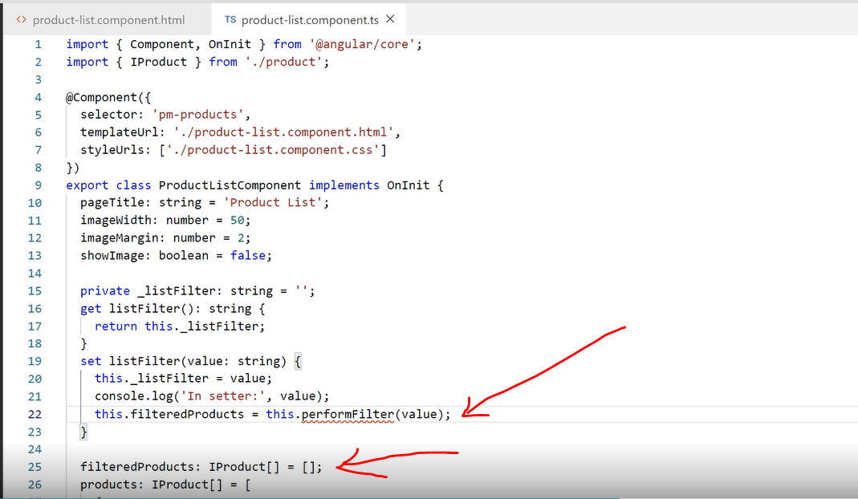

Step 2:

Then add performFilter method to compare lowercase:

The box below filters and return the

Lower case listFilter and productName. Include filter retuns true if the product is equal to filter

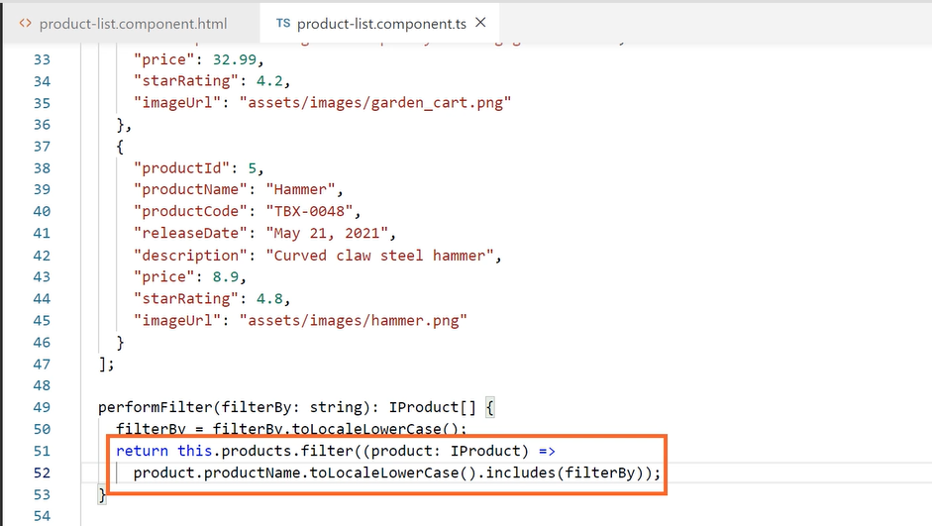

Step 3:

Change product of Products to product of filteredProducts property as below.

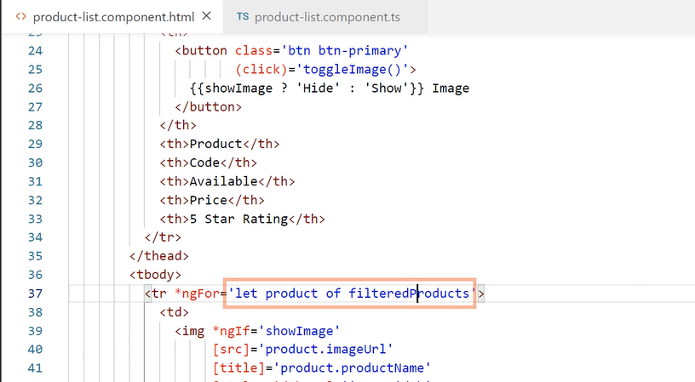

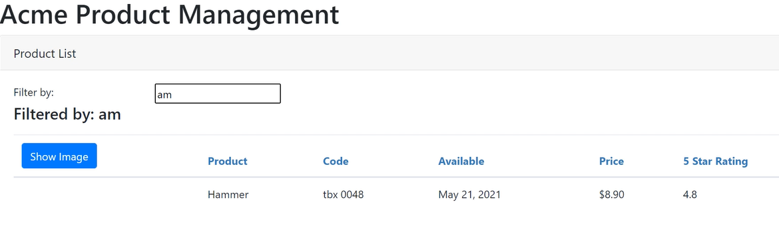

**Building Nested components**

Below is nested component pictorial example: nested component can be communicated. Each are fully encapsulated. It allows passing data back and forth. We can use the component as a directive. We use component selector as custom HTML tag.

<body>

<pm-root></pm-root>

</body>

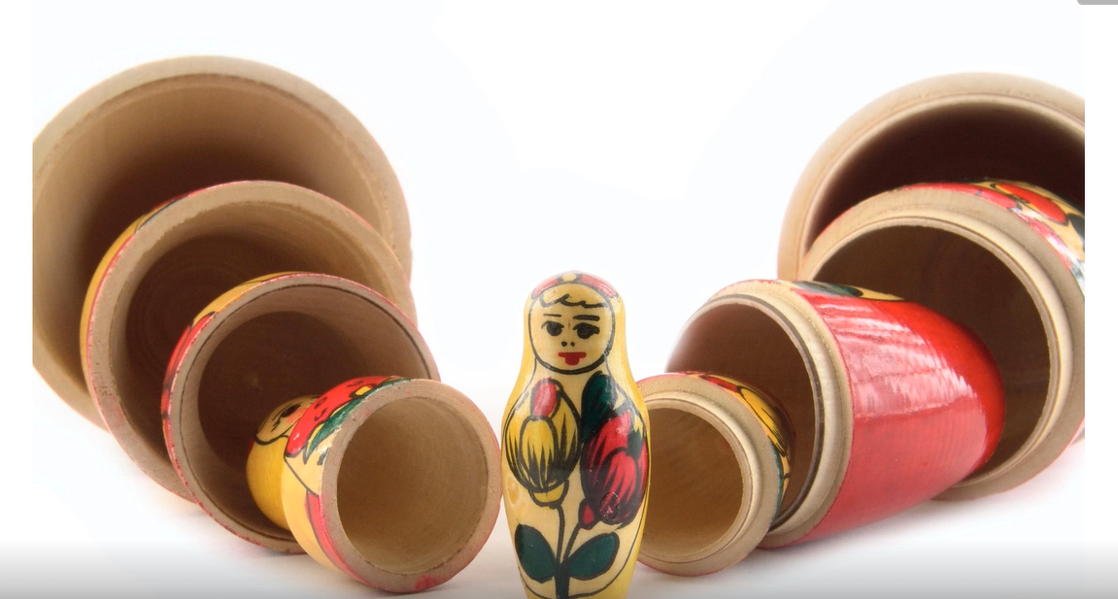

If they have selector defined, it will become a nestable component.

It optionally communicates with the container. (assign data using @input)

Start component – we use nested component in the application architecture now.

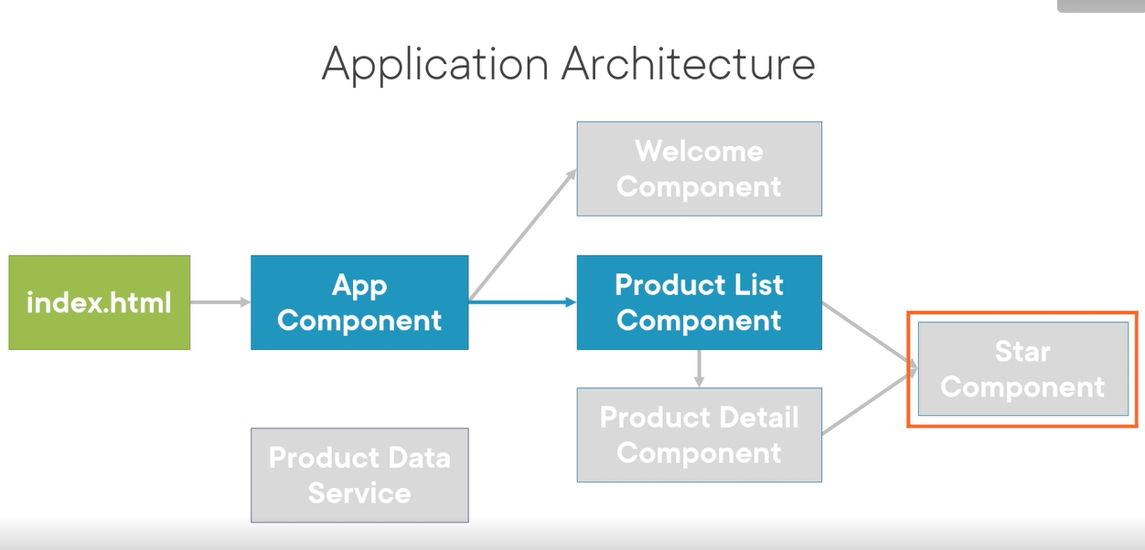

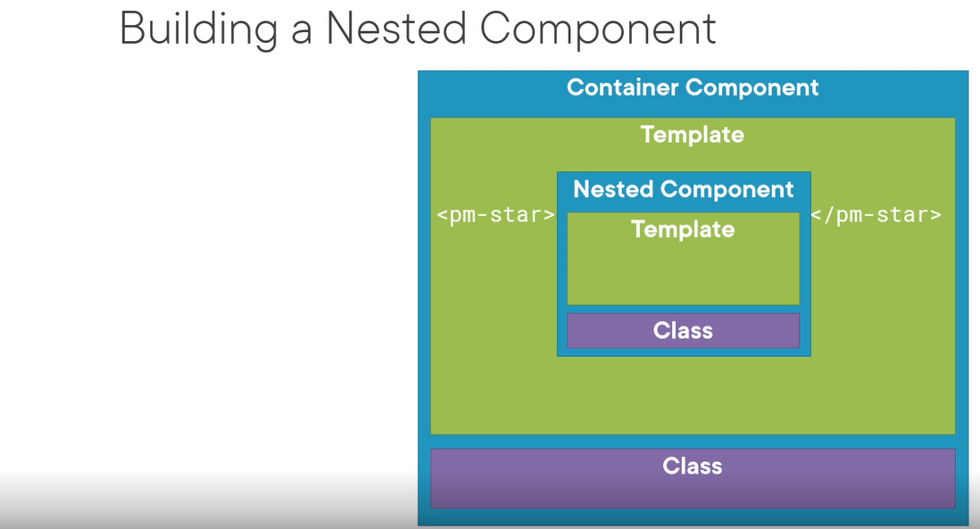

Step 1:

Create a star components in shared folder.

star.component.css

star.component.ts

star.component.html

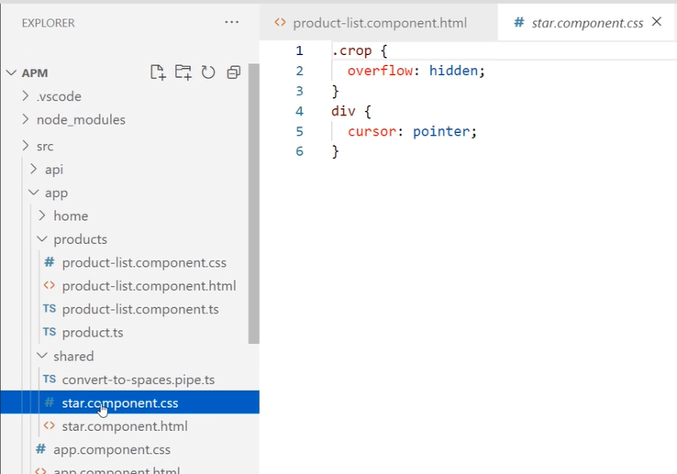

Add component decorator:

Import { Component } from “@angular/core”;

@component({

Selector: ‘pm-star’,

templateUrl: ‘./start.component.html’,

styleUrls: [‘./star/component.css’]

})

Export class startComponent {

}

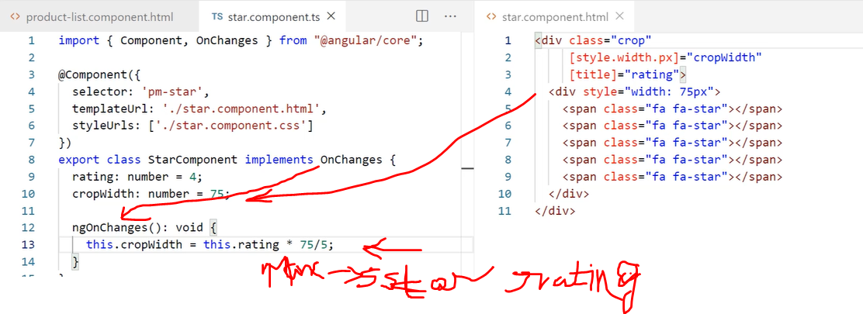

2 properties in the class needs to be added for [style.width.px] and [title] in the above HTML.

Crop can set 4.5 start to 5 starts by setting the crop width.

[title] = ‘rating”; 🡨- this is property binding to display numeric rating.

Using a nested component as a directive:

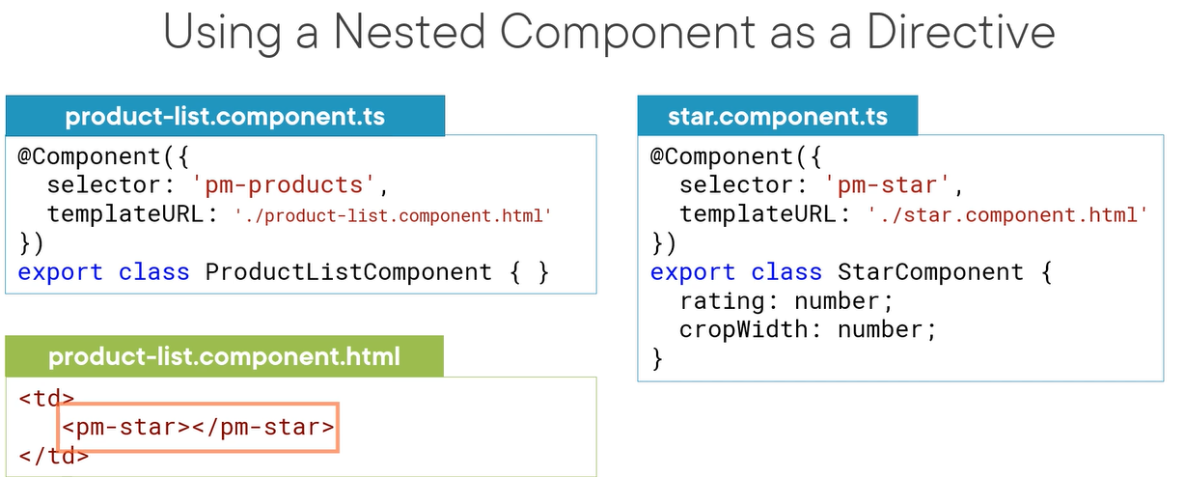

But we want to pass the property as input decorator in export class: @input()

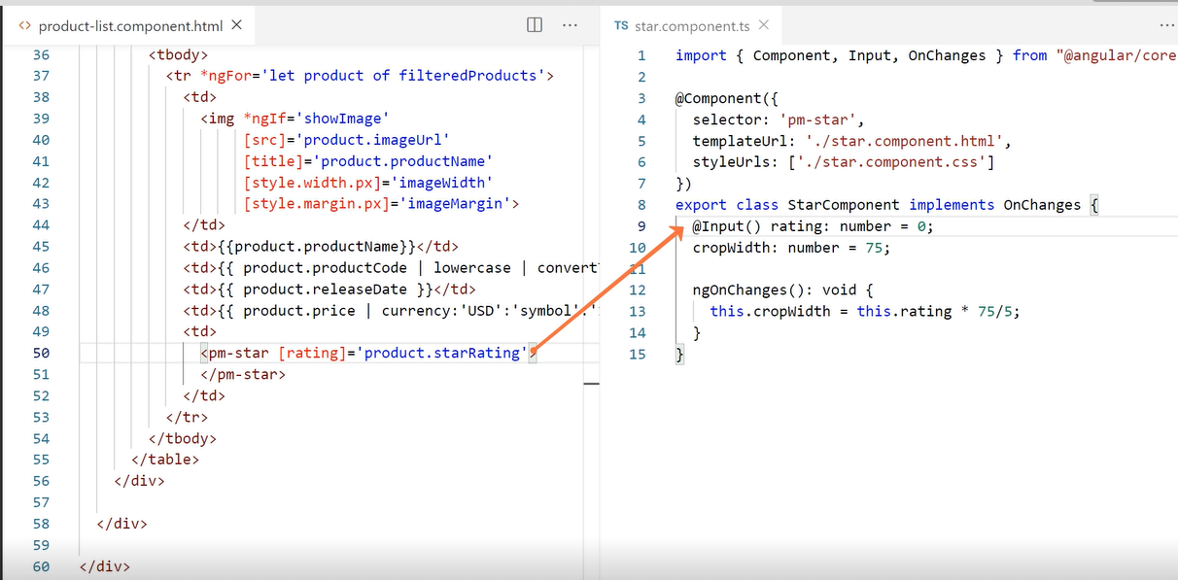

Nest to send the data back to the container:

create onClick() event to react when the user clicks the rating buttons on the browser.

Bind method onClick() to the component as below

onClick is void because it wont send back anything.

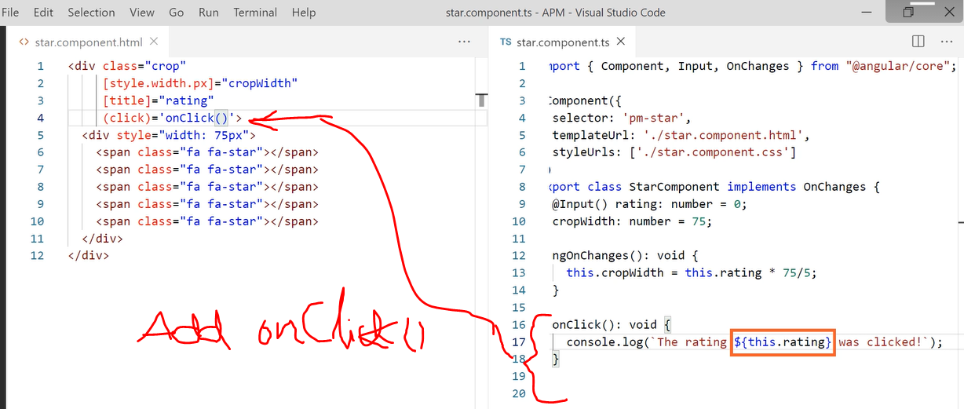

When we click on star rating it shows on the console…as below:

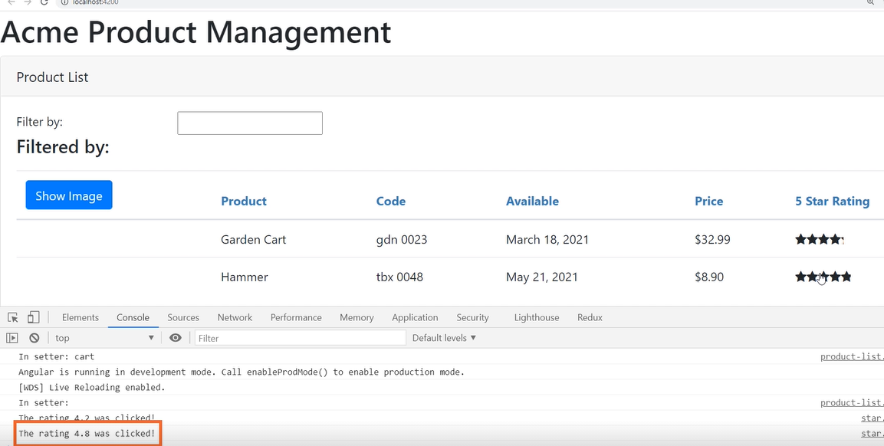

@Output decorator to send the data back to the container. But it must be an event:

In this example we notify event with string data

We access the data using $event

Add ratingClicked property to the component. And pass string to the eventEmitter. Add @Output decorator. Add Output to the import statement

onClicke() event, add ratingClicked.emit event.

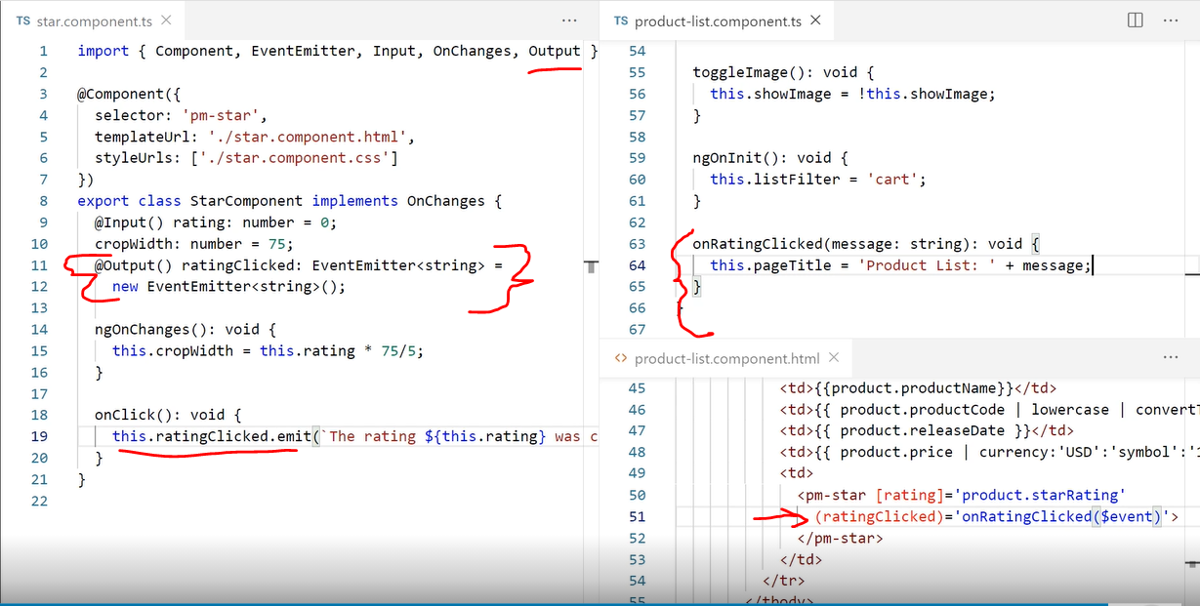

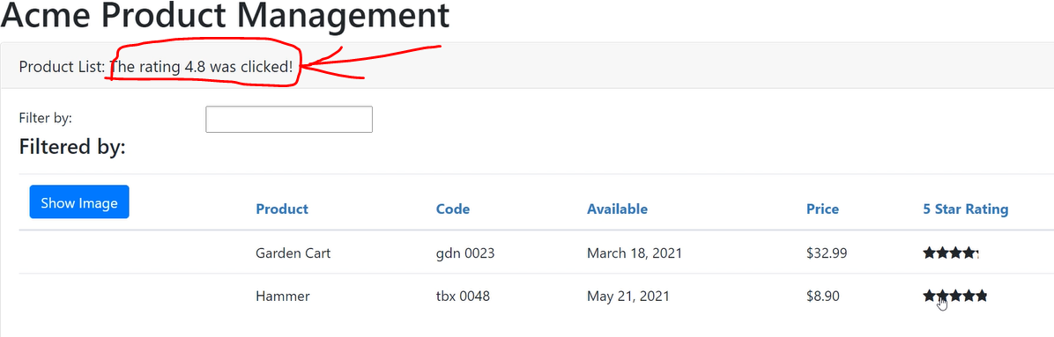

**Services and Dependency Injection**

We built services to communicate data between components – uses dependency injection.

Service is a class with a focused purpose.

We understand how it works, build, register and injecting the service.

We earlier hardcoded product list. Now we use product data and create a service.

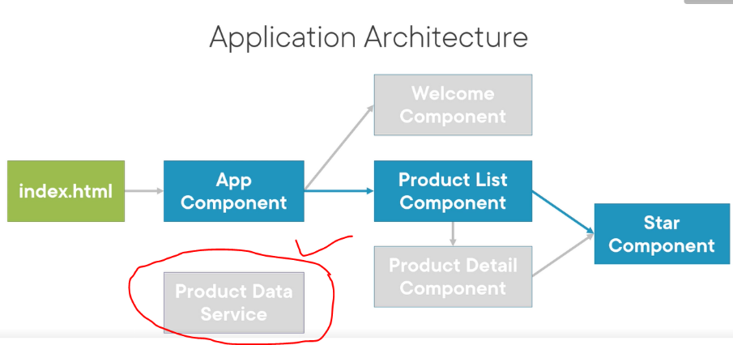

Register the services with angular. It creates single instance. It builts injector. Injector creates and manges injector. Angular manages instance of 3 services…log, math and SVC.

If the component need services, the component class defins the service as a dependency and the angular injector then injects the service class insanciated. So it is called as dependency injection.

It provides better management. It allows share the data ..

Dependency inj is a coding pattern in which a class receives the instance of the object it needs from the exernal source creating them itself.

Building the services: using 3 steps below

1. Create service class ex: ProductServices
2. Define the metadata with a decorator @Injectable
3. Import when we need import { Injectable } from ‘@Angular/Core’

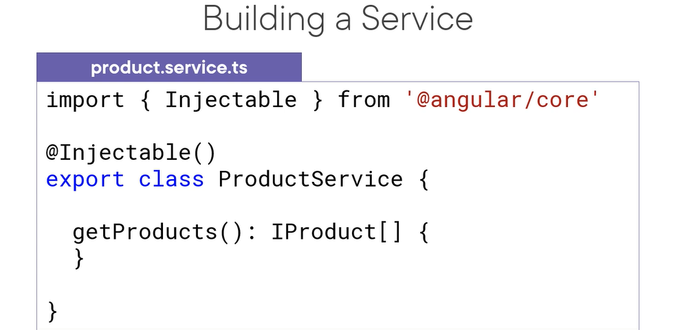

Create a new file in products folder: product.service.ts  
Now create service class in it as follows.

Import injector, add @Injector decorator. Then getProduct() method

We register the service with angular injector.

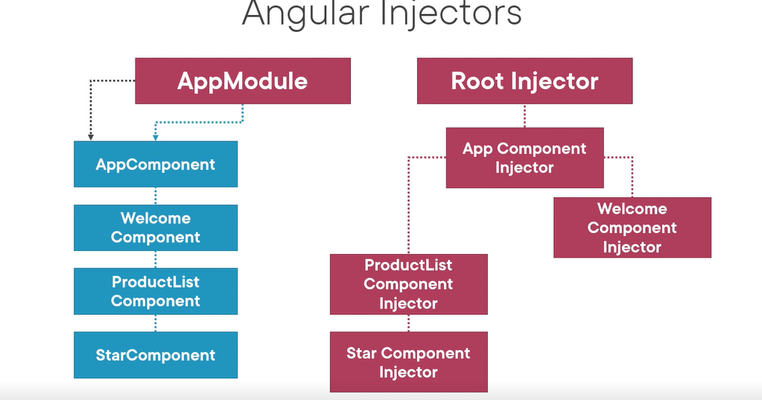

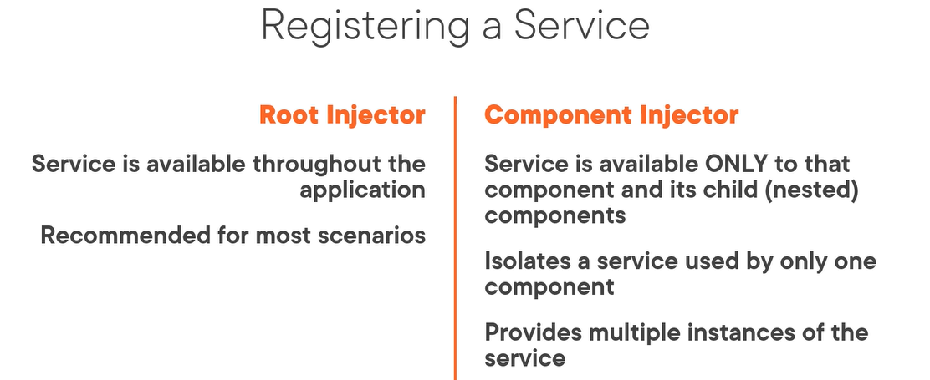

Example below to register the service at root level or at component level:

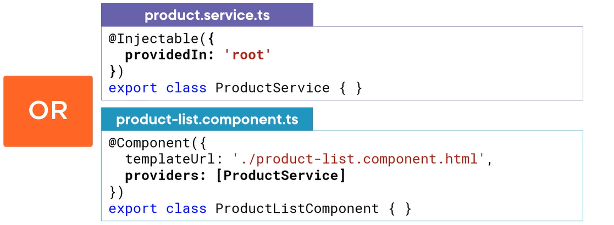

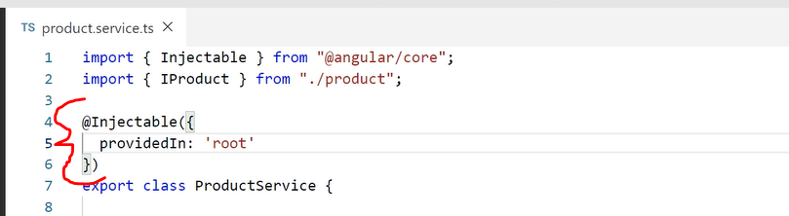

With the above code, the component can be available for injection from any where in the application.

Now let’s see how to inject the service:

We need a constructor function for the component to create.

We identify the dependency in the constructor paramaneter.

And preiave _productService to hold the

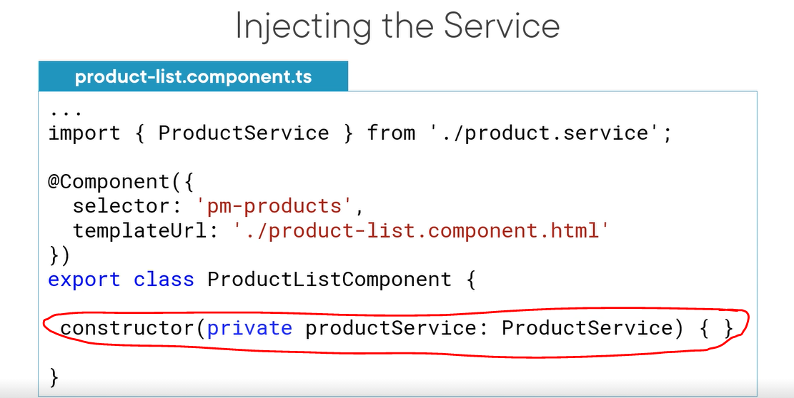

Let us do changes in the code now.

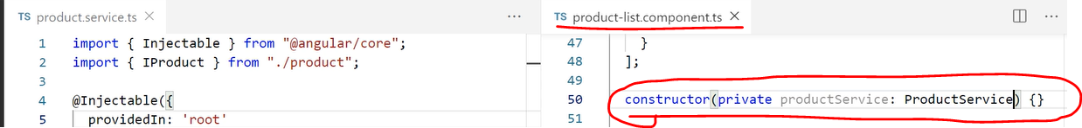

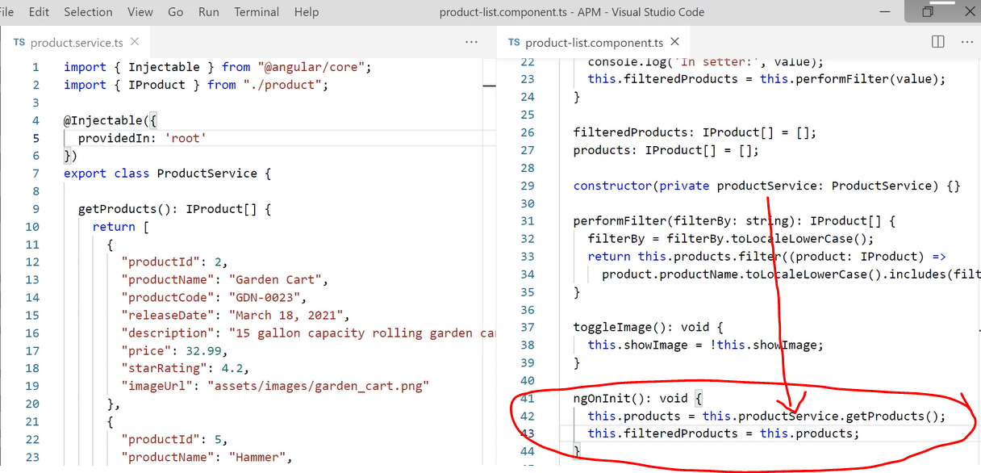

Lets see result now:

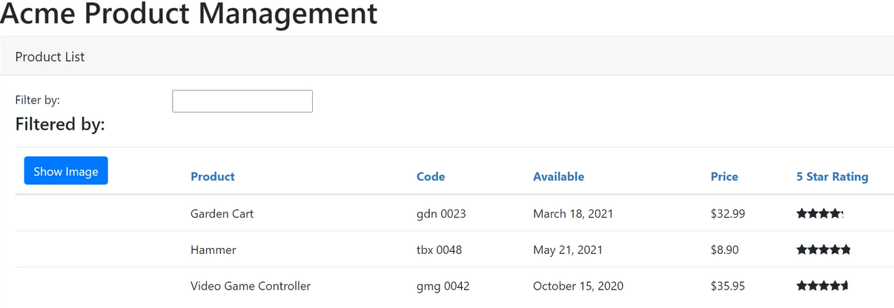

Below is the service checklist:

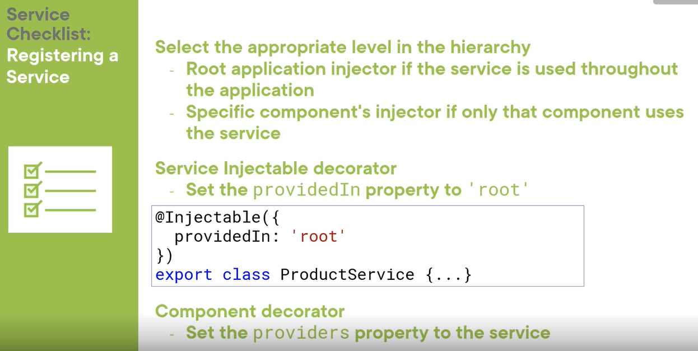

**Retrieving data using HTTP**

How to get data from DB into the view?

We use HTTP with observables using the data.

We learn

1. Observable and reactive Extensions **RxJS** (is a library for composing data using observables**)**
2. Sending an HTTP request (asynchronous)
3. Exception Handling
4. Subscribing to an Observable

Observables need subscribe method.

Now we replace the hardcoded data with HTTP calls.

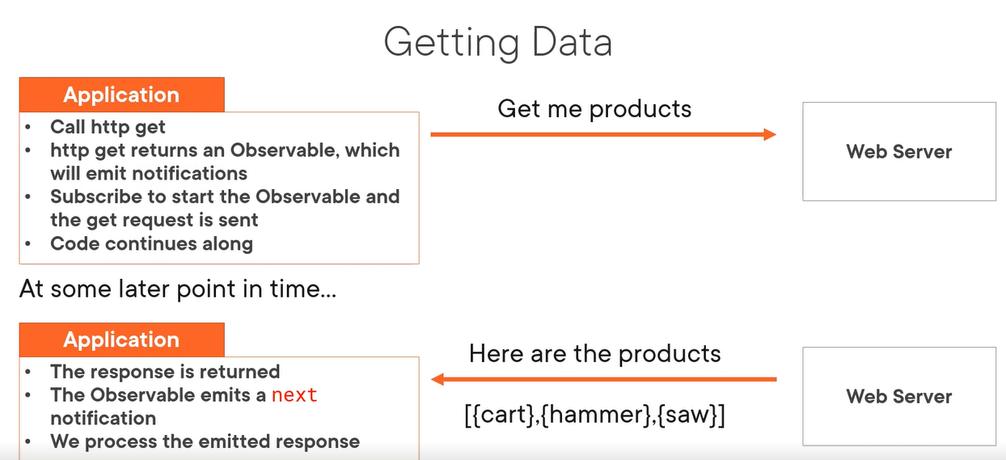

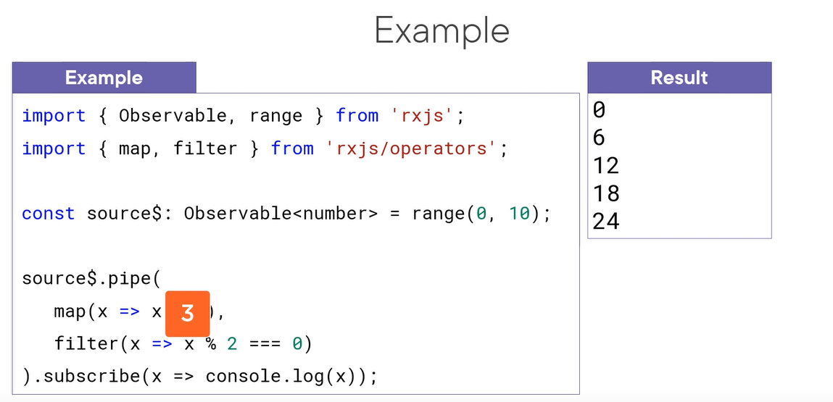

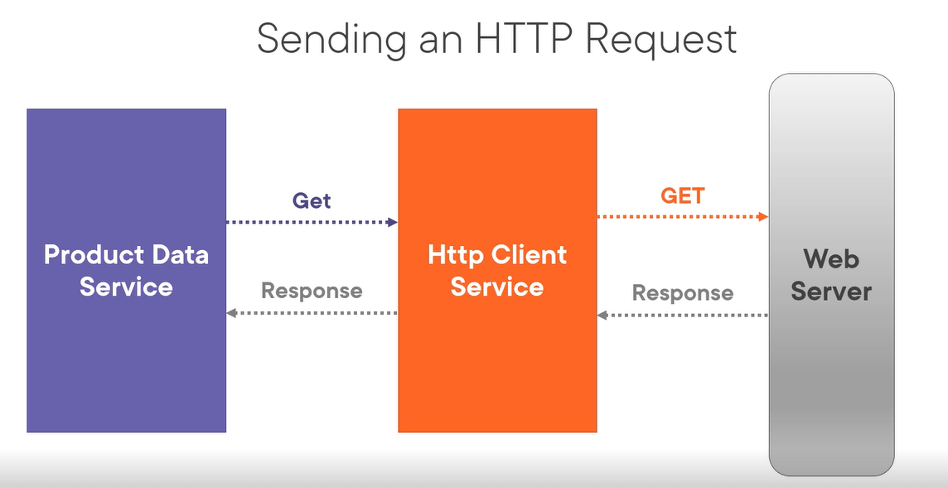

Now the application architecture looks like below:

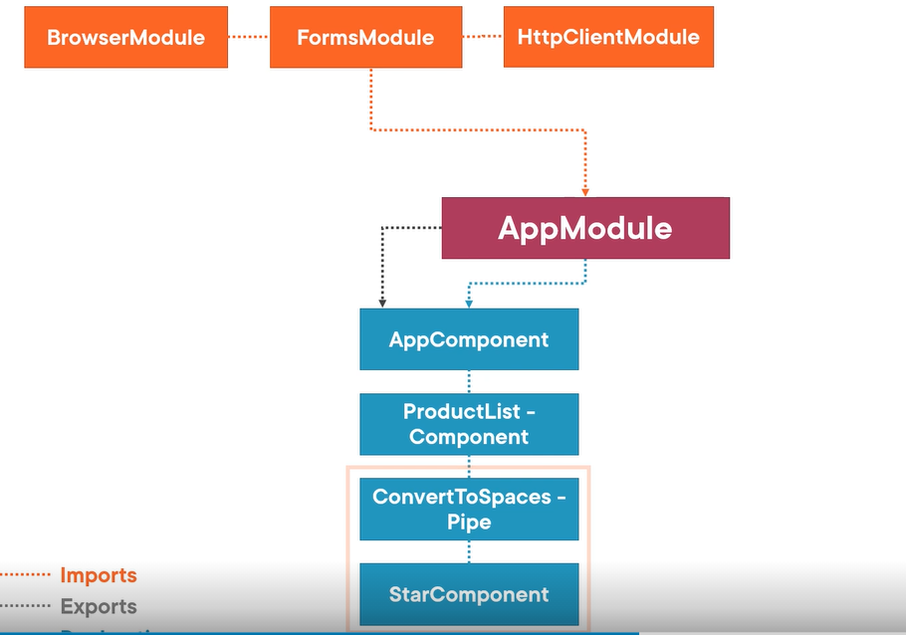

Demo to setup HTTP request to get the products to productList

Step 1 – add http client module to import. And import it from angular/common/http as below:

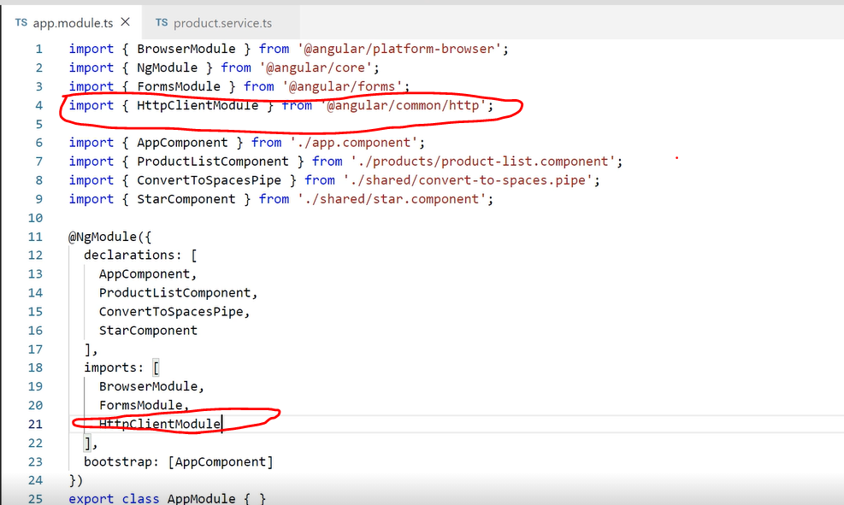

We need to add exception handling while we retirev the data from external source either from HTTP or frm the database:

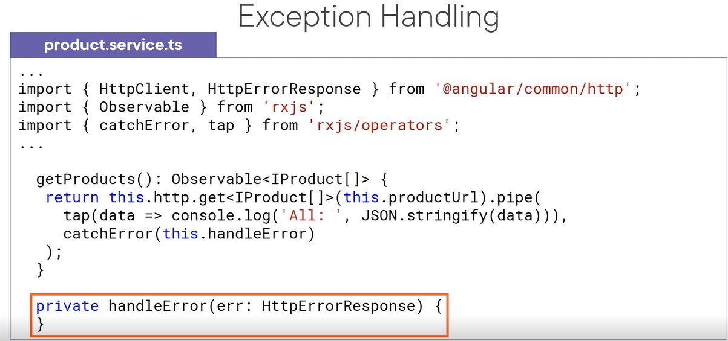

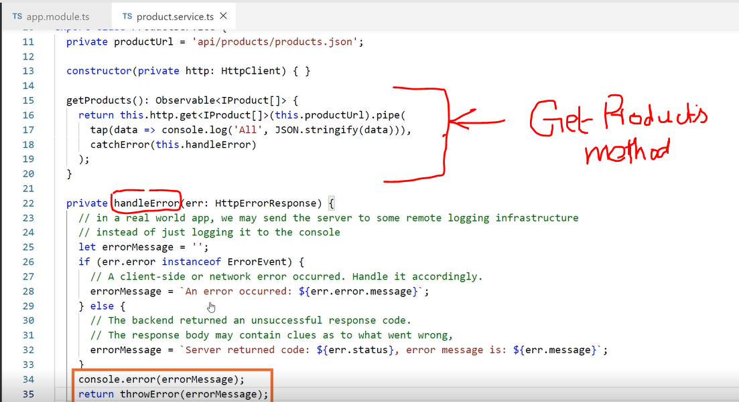

We cant see the result because we have not been subscribed to the ubservabe.

How to subscribte an observable?

x.subscribe()

x.subscribe(observer)

x.subscribe ({

nextFn,

efforFn,

completeFnn

})

Const sub = x.subscribe ({

nextFn,

errorFn,

completeFn

})

Unsubscribe once it is emitting the single response. Several ways to unsubscribe. 1. Sore it in variable. Implement onDestroy method.

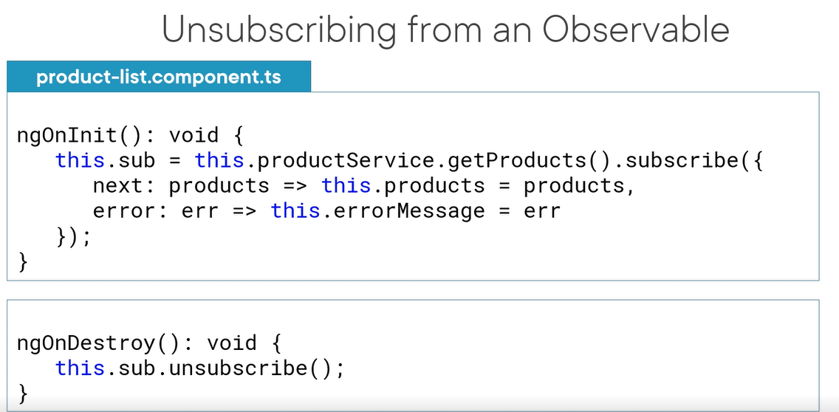

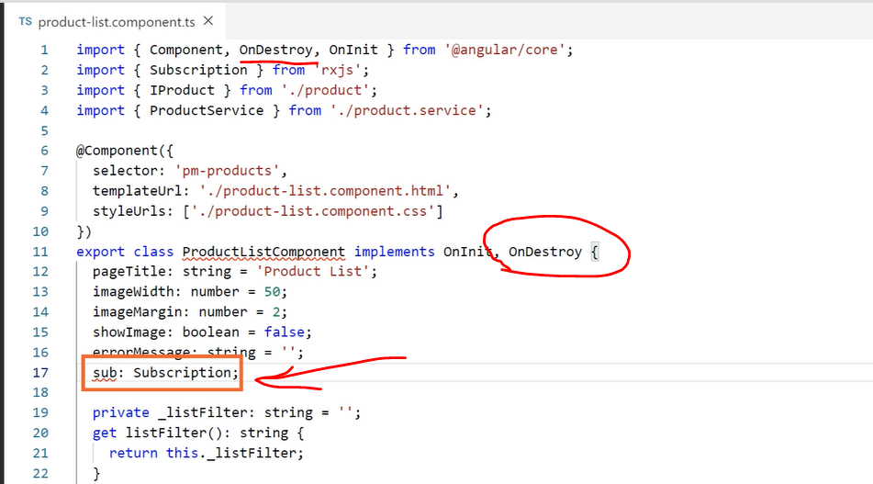

Change above sub: subscription to sub! Subscription;

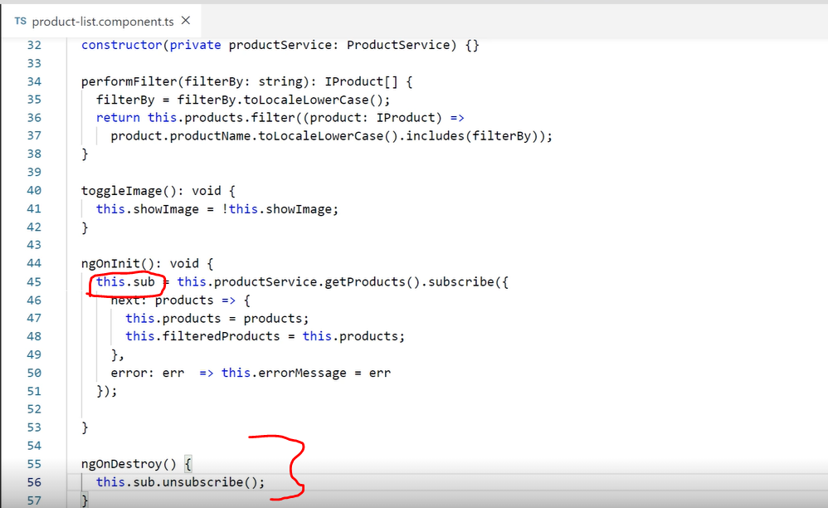

**Navigation and routing:**

Product detail component:

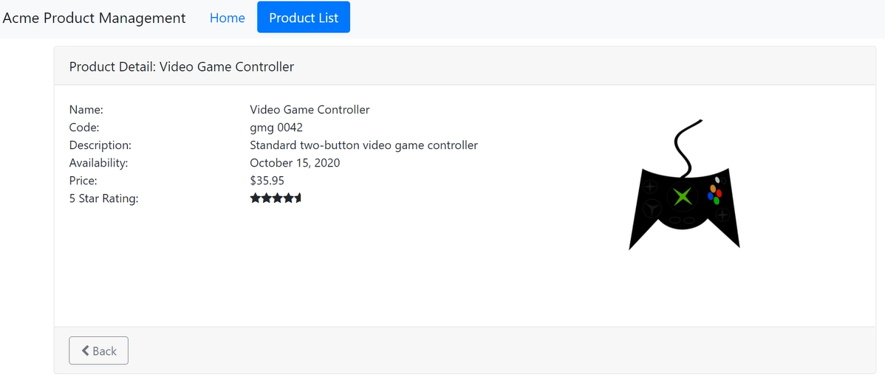

Create product components product-detail using CLI command as follows:

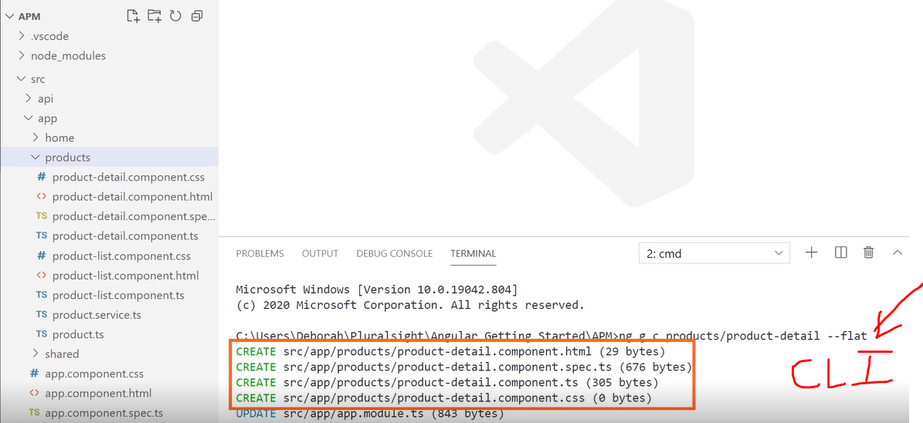

Above we can see product-detail components created in ‘products’ folder.

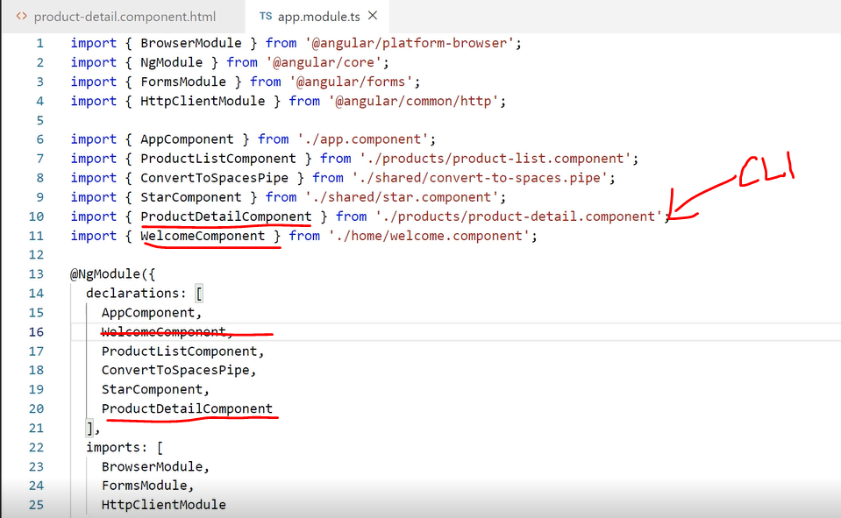

CLI adds the product-detail component in APP-module. We add welcome component. And import.

Angular is single page application SPA. 100s of view take turn and appear on that page. We consider routing to display each page on it.

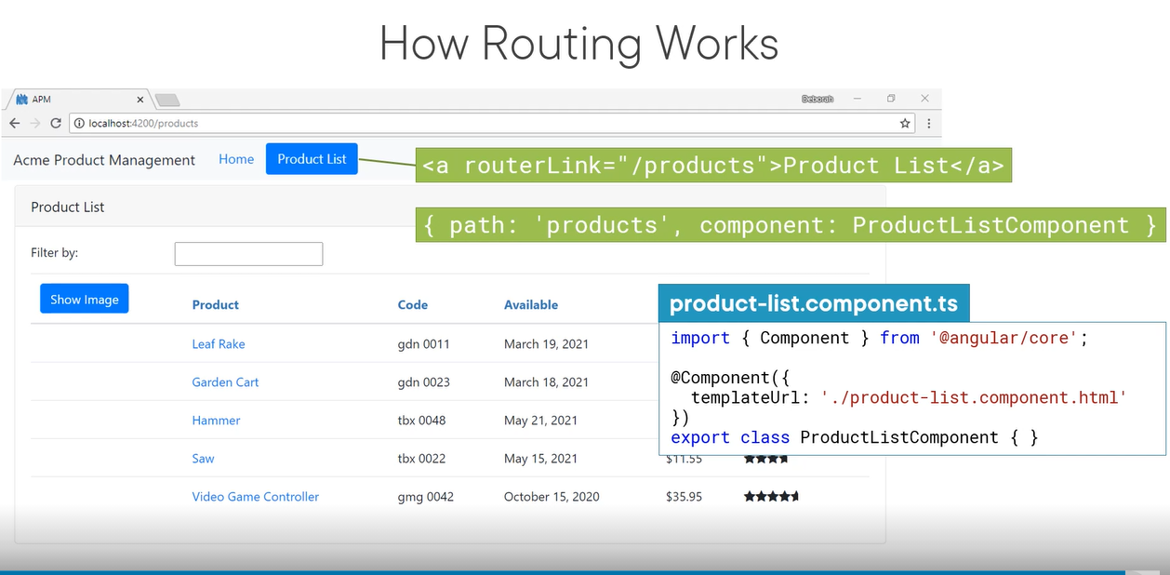

Below example for routing configuration:

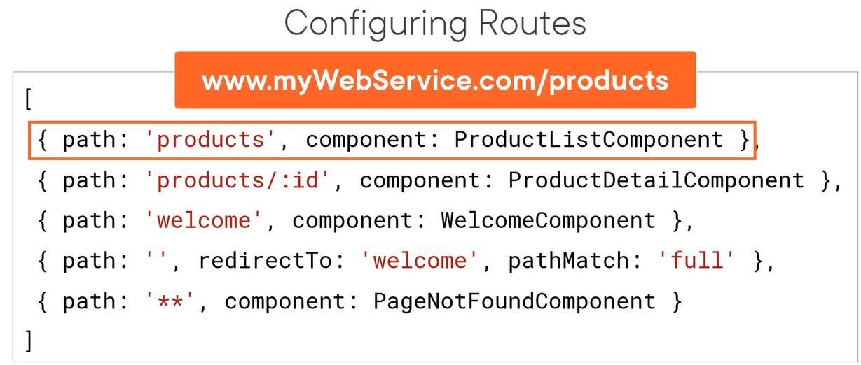

Setup base in index.html: <base href=”/”>

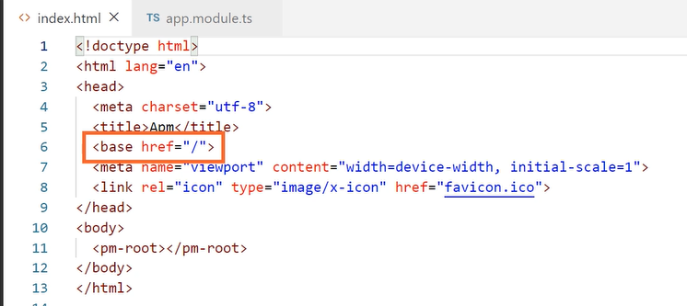

Go to app module : configure definition..

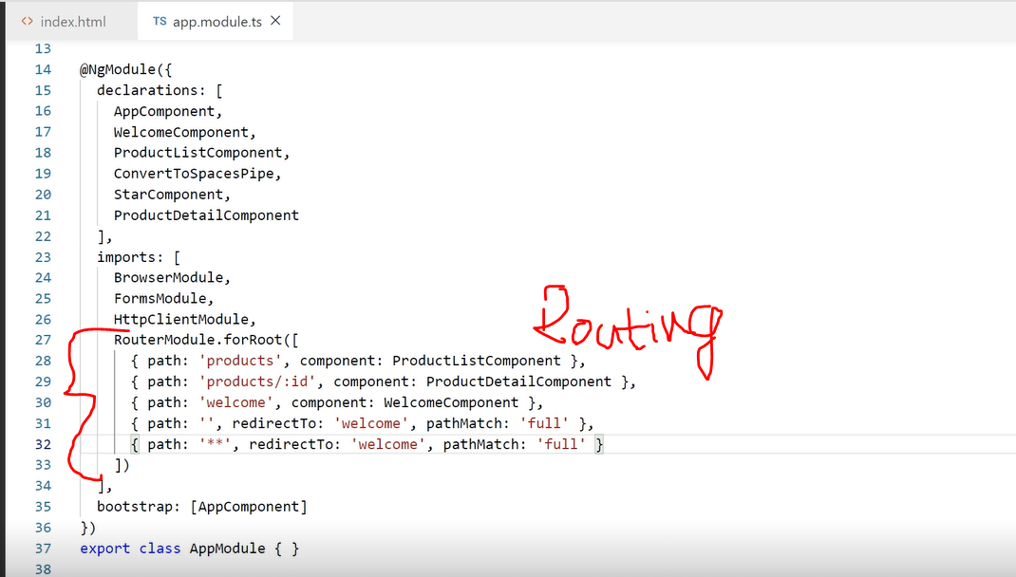

Navigating the application routes:

* Menu option, link, image or button that activates route
* Typing the URL in the address bar
* The browser’s forward or backward button.

We need to handle the first one only. Next two will be handled by route configuration.

We use router link directive as below:

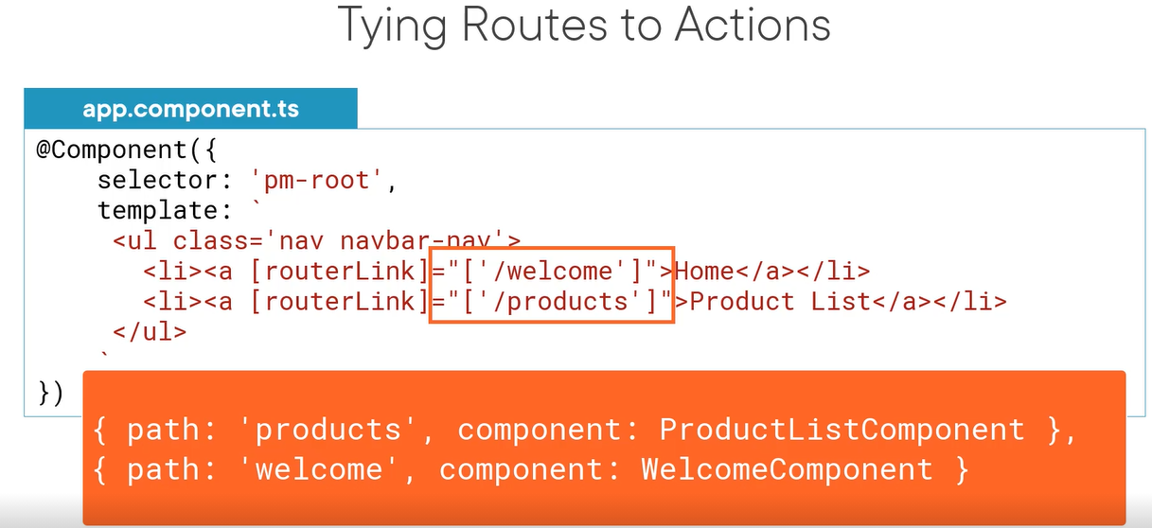

We add menu now to the root ‘app.cmponent’

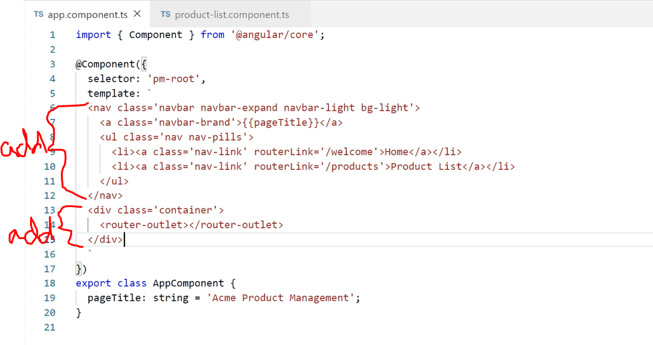

Also remove the product-list component:

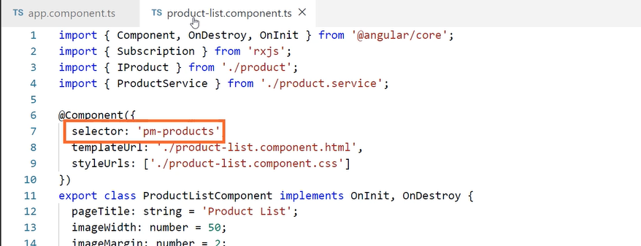

Add router parameter in the app components as above.

Welcome page activates as below when we initiate the application:

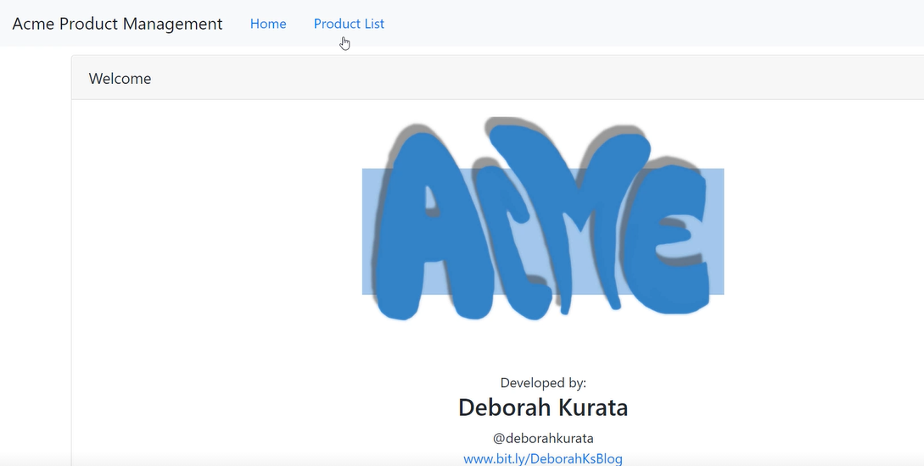

When we click product list, product list link is activated.

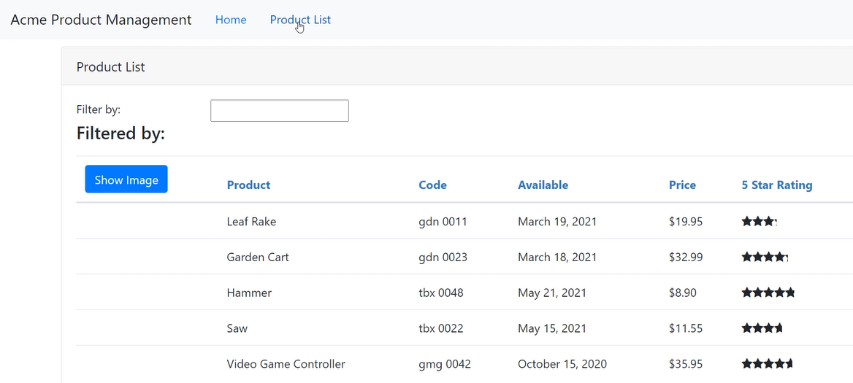

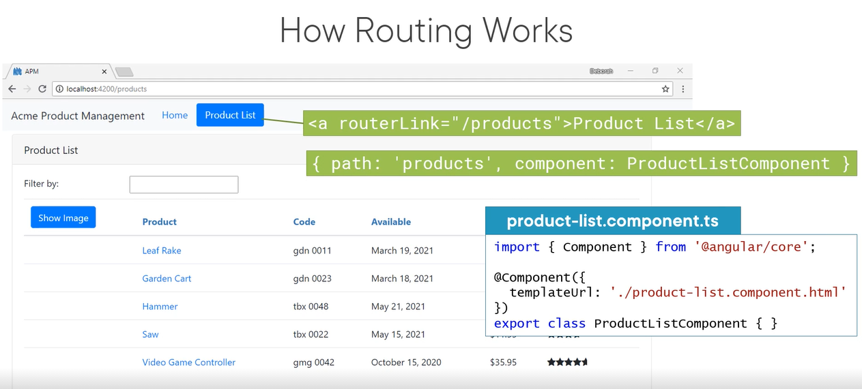

**12 Additional Routing Techniques:**

-need to protect route with guards

-add parameters to route

We have already tagged product ID as below: which knows the product details to display by ‘/:id’

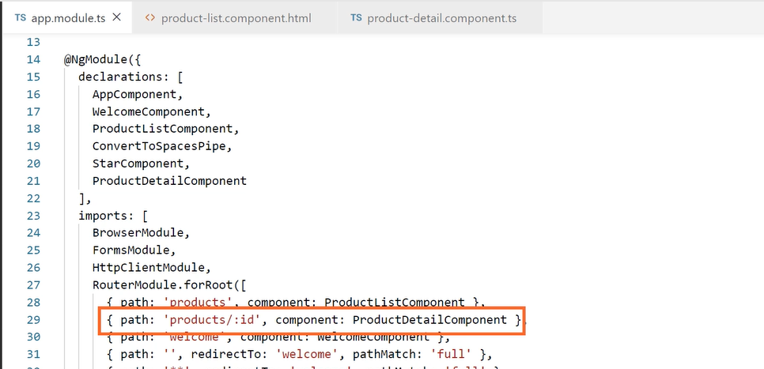

Then we have to change the product list view as below to get the link for each product name.

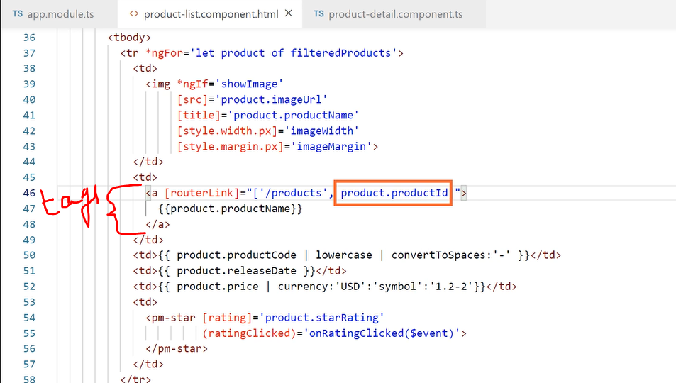

Now if we see the browser, the product names have hyperlinks. If we click the link, we can see the product details.

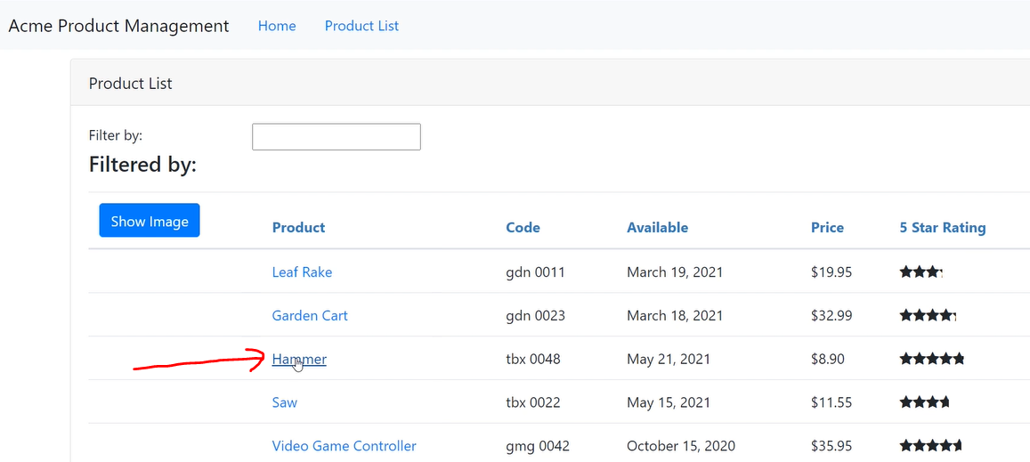

Now we have to add product detail parameter when clicked the product name.

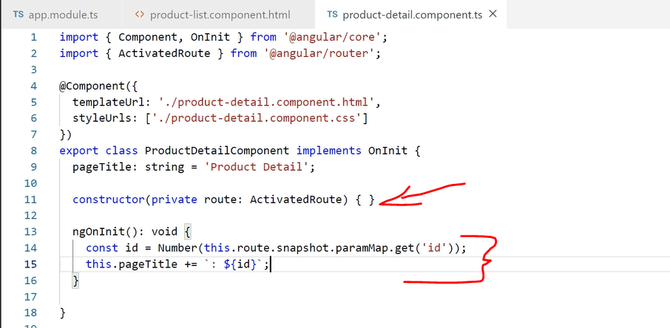

We got result as below:

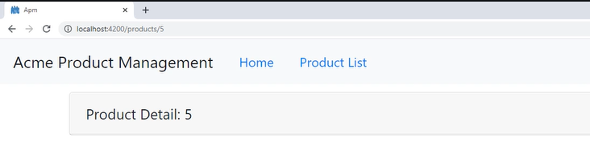

Now how to prevent and handling null value:

Use safe navigation operator value ‘?’ for null. It gurds agains null or undefined values. And it simply returns null.

But we can add ngIf:

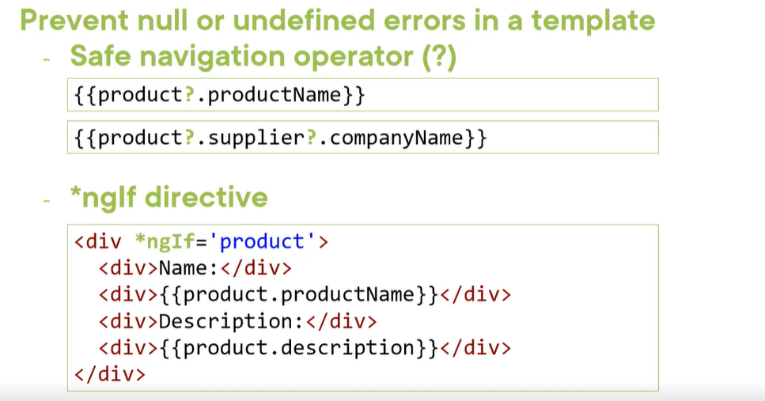

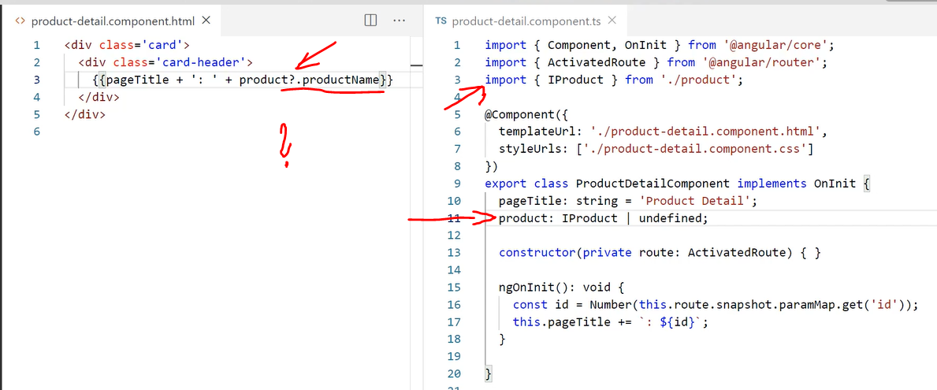

Adding back button to the product details at the bottom:

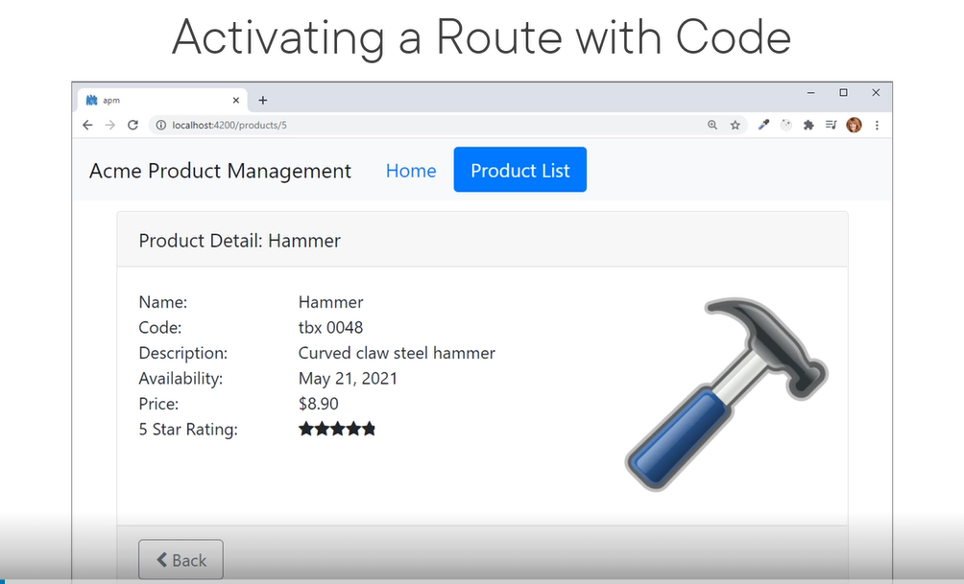

Because we hard coded the product, it wont show the details but it show the back button with below changes.

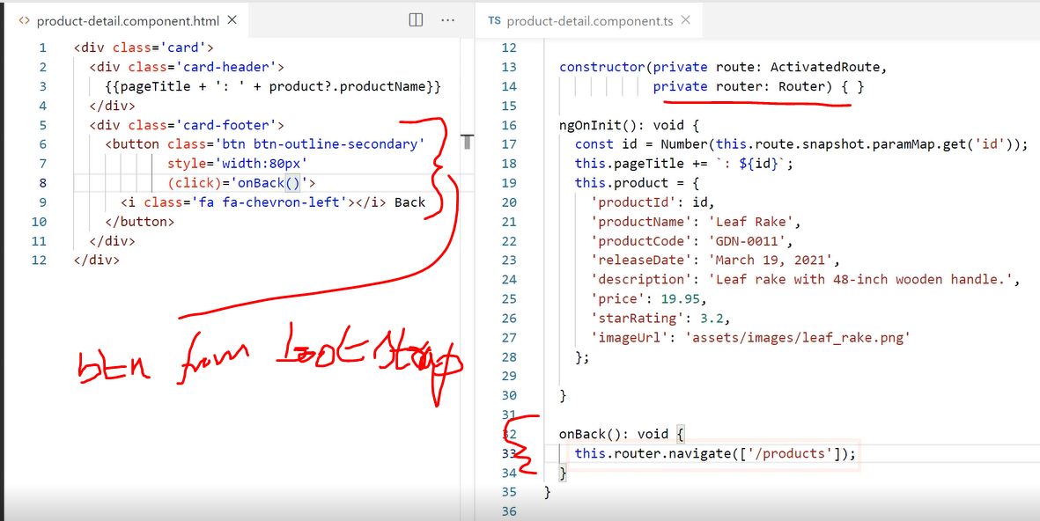

Protect ROUTES with guard:

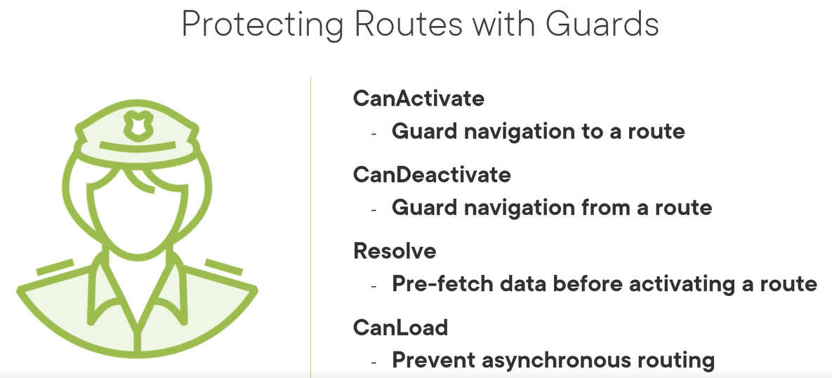

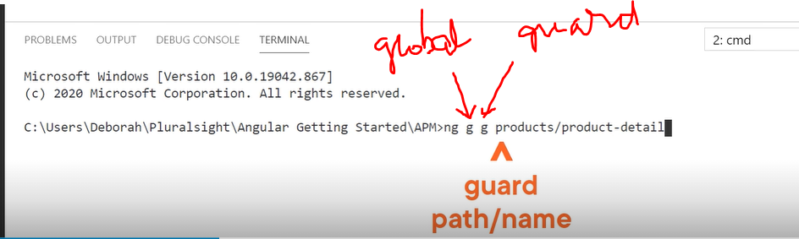

During installing the above command, select type of guard after this:

Select > (*)canActivate -> this will install the guard in products/product-detail

CLI created boiler plate for us with the component product-detail.guard.ts:

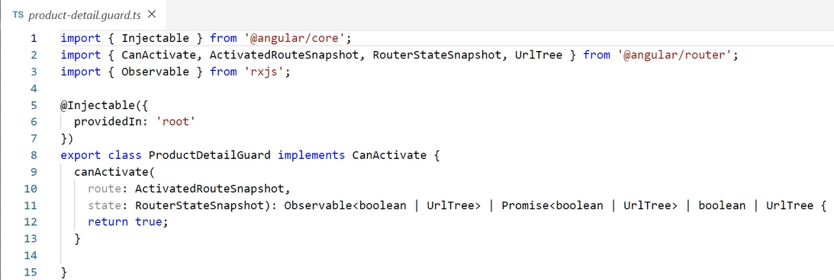

Now we need to check the route url to see whether iD is valid. If not, we route to the product list.

Now read parameter from the route.

Check for not a number NaN value or value less than 1.

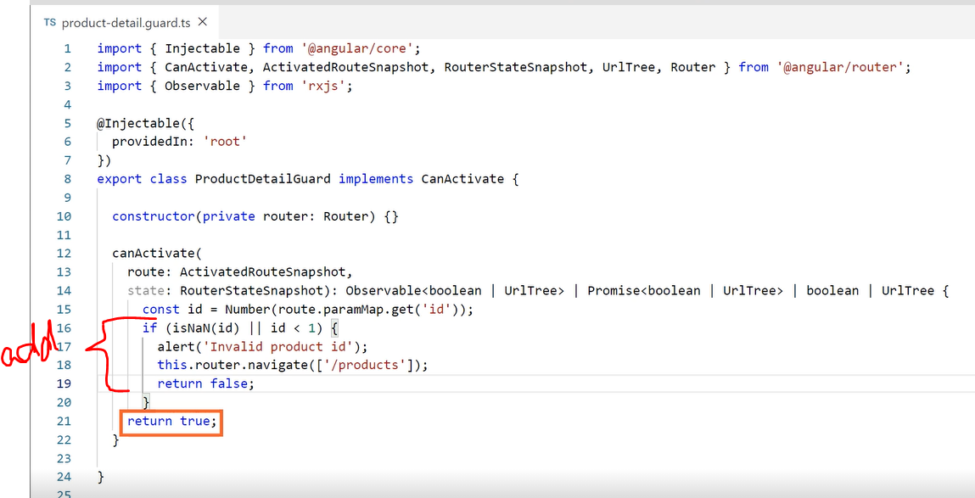

Now add canActivate property to the route definition as below:

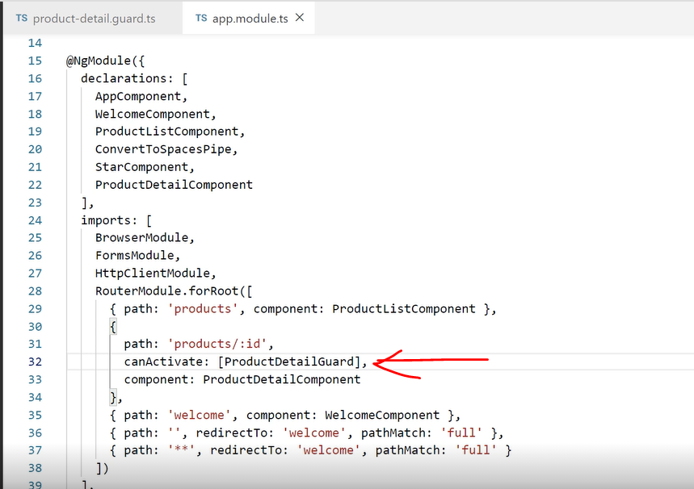

Now if we change the url from product ID to ‘0’ or any other invalid number, it throws the error. Once we click ok, it again goes to the product details page:

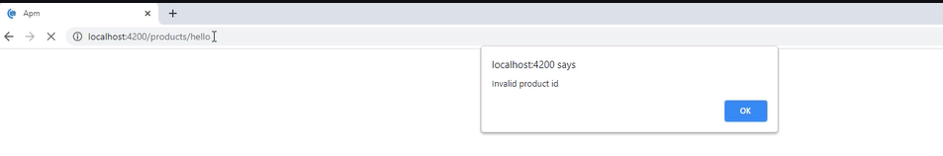

**Angular Modules**

<https://app.pluralsight.com/course-player?clipId=fe7b0363-07f3-4265-96e8-ff5e79926358>